eda-project-amcat

October 2, 2024

[1]:

0.1 Epanagalla Ramakrishna

0.2 ID : : IN9240255

* 1. **Step 1**

## ANALYSIS OF AMCAT DATA

The dataset originates from the Aspiring Minds Employment Outcome 2015 (AMEO) and focuses on the employment outcomes of engineering graduates. It includes a mix of demographic informa- tion, educational details, standardized test scores in cognitive and technical skills, and personality traits, across approximately 4000 data points. Key features include:

**Personal and Demographic Information:** Includes the candidate’s ID, gender, date of birth, job designation, job city, and salary.

**Educational Background:** Covers high school and college academic performances, the tier of the college, specialization, degree, and graduation year.

**Technical and Cognitive Skills:** Scores from AMCAT tests in areas such as English, logical reasoning, quantitative ability, computer programming, and various engineering disciplines.

**Personality Traits:** Scores in conscientiousness, agreeableness, extraversion, neuroticism, and openness to experience.

## Objective:

The primary aim is to analyze the relationship between the educational background, skillset, and personality traits of engineering graduates and their employment outcomes, such as job roles and salaries. This includes validating industry claims about salary expectations for specific roles and exploring the influence of gender on specialization preferences.

**import pandas as pd import numpy as np**

**import matplotlib.pyplot as plt**

**from datetime import** datetime, timedelta

**import seaborn as sns**

C:\ProgramData\Anaconda3\lib\site-packages\scipy\ init .py:155: UserWarning: A NumPy version >=1.18.5 and <1.25.0 is required for this version of SciPy (detected version 1.26.4

warnings.warn(f"A NumPy version >={np_minversion} and <{np_maxversion}"

[2]:

df = pd.read_csv("AMCAT.csv")

[3]:

df.head()

# Step 2

|  |  |  |  |  |  |  |
| --- | --- | --- | --- | --- | --- | --- |
| [3]: |  | Unnamed: 0 | ID | Salary | DOJ | DOL \ |
|  | 0 | train | 203097 | 420000.0 | 01-06-2012 00:00 | present |
|  | 1 | train | 579905 | 500000.0 | 01-09-2013 00:00 | present |
|  | 2 | train | 810601 | 325000.0 | 01-06-2014 00:00 | present |
|  | 3 | train | 267447 | 1100000.0 | 01-07-2011 00:00 | present |
|  | 4 | train | 343523 | 200000.0 | 01-03-2014 00:00 | 01-03-2015 00:00 |

|  |  |  |  |  |  |
| --- | --- | --- | --- | --- | --- |
| Designation | | JobCity | Gender DOB | | 10percentage \ |
| 0 senior quality engineer | | Bangalore | f 19-02-1990 00:00 | | 84.3 |
| 1 assistant manager | | Indore | m 04-10-1989 00:00 | | 85.4 |
| 2 systems engineer | | Chennai | f 03-08-1992 00:00 | | 85.0 |
| 3 senior software engineer | | Gurgaon | m 05-12-1989 00:00 | | 85.6 |
| 4 get | | Manesar | m 27-02-1991 00:00 | | 78.0 |
| … ComputerScience MechanicalEngg ElectricalEngg TelecomEngg | | | | | CivilEngg \ |
| 0 … | -1 | -1 | -1 | -1 | -1 |
| 1 … | -1 | -1 | -1 | -1 | -1 |
| 2 … | -1 | -1 | -1 | -1 | -1 |
| 3 … | -1 | -1 | -1 | -1 | -1 |
| 4 … | -1 | -1 | -1 | -1 | -1 |

|  |  |  |  |  |
| --- | --- | --- | --- | --- |
| conscientiousness | agreeableness | extraversion | nueroticism | \ |
| 0 0.9737 | 0.8128 | 0.5269 | 1.35490 |  |
| 1 -0.7335 | 0.3789 | 1.2396 | -0.10760 |  |
| 2 0.2718 | 1.7109 | 0.1637 | -0.86820 |  |
| 3 0.0464 | 0.3448 | -0.3440 | -0.40780 |  |
| 4 -0.8810 | -0.2793 | -1.0697 | 0.09163 |  |

[4]:

df.shape

openess_to_experience 0 -0.4455

1 0.8637

2 0.6721

3 -0.9194

4 -0.1295

[5 rows x 39 columns]

[4]: (3998, 39)

[5]:

df.columns

[5]: Index(['Unnamed: 0', 'ID', 'Salary', 'DOJ', 'DOL', 'Designation', 'JobCity', 'Gender', 'DOB', '10percentage', '10board', '12graduation', '12percentage', '12board', 'CollegeID', 'CollegeTier', 'Degree', 'Specialization', 'collegeGPA', 'CollegeCityID', 'CollegeCityTier', 'CollegeState', 'GraduationYear', 'English', 'Logical', 'Quant', 'Domain', 'ComputerProgramming', 'ElectronicsAndSemicon', 'ComputerScience', 'MechanicalEngg', 'ElectricalEngg', 'TelecomEngg', 'CivilEngg', 'conscientiousness', 'agreeableness', 'extraversion', 'nueroticism', 'openess_to_experience'],

dtype='object')

[6]:

df.describe()

|  |  |  |  |  |  |  |  |
| --- | --- | --- | --- | --- | --- | --- | --- |
| [6]: |  | ID | Salary | 10percentage | 12graduation | 12percentage \ | |
|  | count | 3.998000e+03 | 3.998000e+03 | 3998.000000 | 3998.000000 | 3998.000000 | |
|  | mean | 6.637945e+05 | 3.076998e+05 | 77.925443 | 2008.087544 | 74.466366 | |
|  | std | 3.632182e+05 | 2.127375e+05 | 9.850162 | 1.653599 | 10.999933 | |
|  | min | 1.124400e+04 | 3.500000e+04 | 43.000000 | 1995.000000 | 40.000000 | |
|  | 25% | 3.342842e+05 | 1.800000e+05 | 71.680000 | 2007.000000 | 66.000000 | |
|  | 50% | 6.396000e+05 | 3.000000e+05 | 79.150000 | 2008.000000 | 74.400000 | |
|  | 75% | 9.904800e+05 | 3.700000e+05 | 85.670000 | 2009.000000 | 82.600000 | |
|  | max | 1.298275e+06 | 4.000000e+06 | 97.760000 | 2013.000000 | 98.700000 | |
|  | | CollegeID | CollegeTier | collegeGPA | CollegeCityID | CollegeCityTier | \ |
| count | | 3998.000000 | 3998.000000 | 3998.000000 | 3998.000000 | 3998.000000 |  |
| mean | | 5156.851426 | 1.925713 | 71.486171 | 5156.851426 | 0.300400 |  |
| std | | 4802.261482 | 0.262270 | 8.167338 | 4802.261482 | 0.458489 |  |
| min | | 2.000000 | 1.000000 | 6.450000 | 2.000000 | 0.000000 |  |
| 25% | | 494.000000 | 2.000000 | 66.407500 | 494.000000 | 0.000000 |  |
| 50% | | 3879.000000 | 2.000000 | 71.720000 | 3879.000000 | 0.000000 |  |
| 75% | | 8818.000000 | 2.000000 | 76.327500 | 8818.000000 | 1.000000 |  |
| max | | 18409.000000 | 2.000000 | 99.930000 | 18409.000000 | 1.000000 |  |
| … ComputerScience MechanicalEngg ElectricalEngg TelecomEngg \ | | | | | | | |

CivilEngg conscientiousness agreeableness extraversion \ count 3998.000000 3998.000000 3998.000000 3998.000000

|  |  |  |  |  |  |
| --- | --- | --- | --- | --- | --- |
| count | … | 3998.000000 | 3998.000000 | 3998.000000 | 3998.000000 |
| mean | … | 90.742371 | 22.974737 | 16.478739 | 31.851176 |
| std | … | 175.273083 | 98.123311 | 87.585634 | 104.852845 |
| min | … | -1.000000 | -1.000000 | -1.000000 | -1.000000 |
| 25% | … | -1.000000 | -1.000000 | -1.000000 | -1.000000 |
| 50% | … | -1.000000 | -1.000000 | -1.000000 | -1.000000 |
| 75% | … | -1.000000 | -1.000000 | -1.000000 | -1.000000 |
| max | … | 715.000000 | 623.000000 | 676.000000 | 548.000000 |

|  |  |  |  |  |
| --- | --- | --- | --- | --- |
| mean | 2.683842 | -0.037831 | 0.146496 | 0.002763 |
| std | 36.658505 | 1.028666 | 0.941782 | 0.951471 |
| min | -1.000000 | -4.126700 | -5.781600 | -4.600900 |
| 25% | -1.000000 | -0.713525 | -0.287100 | -0.604800 |
| 50% | -1.000000 | 0.046400 | 0.212400 | 0.091400 |
| 75% | -1.000000 | 0.702700 | 0.812800 | 0.672000 |
| max | 516.000000 | 1.995300 | 1.904800 | 2.535400 |
|  | nueroticism | openess_to_experience | | |
| count | 3998.000000 | 3998.000000 | | |
| mean | -0.169033 | -0.138110 | | |
| std | 1.007580 | 1.008075 | | |
| min | -2.643000 | -7.375700 | | |
| 25% | -0.868200 | -0.669200 | | |
| 50% | -0.234400 | -0.094300 | | |
| 75% | 0.526200 | 0.502400 | | |
| max | 3.352500 | 1.822400 | | |

[7]:

[8 rows x 27 columns]

df.info()

<class 'pandas.core.frame.DataFrame'> RangeIndex: 3998 entries, 0 to 3997 Data columns (total 39 columns):

# Column Non-Null Count Dtype

|  |  |  |  |  |
| --- | --- | --- | --- | --- |
| 0 Unnamed: 0 | 3998 | non-null |  | object |
| 1 ID | 3998 | non-null |  | int64 |
| 2 Salary | 3998 | non-null |  | float64 |
| 3 DOJ | 3998 | non-null |  | object |
| 4 DOL | 3998 | non-null |  | object |
| 5 Designation | 3998 | non-null |  | object |
| 6 JobCity | 3998 | non-null |  | object |
| 7 Gender | 3998 | non-null |  | object |
| 8 DOB | 3998 | non-null |  | object |
| 9 10percentage | 3998 | non-null |  | float64 |
| 10 10board | 3998 | non-null |  | object |
| 11 12graduation | 3998 | non-null |  | int64 |
| 12 12percentage | 3998 | non-null |  | float64 |
| 13 12board | 3998 | non-null |  | object |
| 14 CollegeID | 3998 | non-null |  | int64 |
| 15 CollegeTier | 3998 | non-null |  | int64 |
| 16 Degree | 3998 | non-null |  | object |
| 17 Specialization | 3998 | non-null |  | object |
| 18 collegeGPA | 3998 | non-null |  | float64 |
| 19 CollegeCityID | 3998 | non-null |  | int64 |

|  |  |  |  |
| --- | --- | --- | --- |
| 20 CollegeCityTier | 3998 | non-null | int64 |
| 21 CollegeState | 3998 | non-null | object |
| 22 GraduationYear | 3998 | non-null | int64 |
| 23 English | 3998 | non-null | int64 |
| 24 Logical | 3998 | non-null | int64 |
| 25 Quant | 3998 | non-null | int64 |
| 26 Domain | 3998 | non-null | float64 |
| 27 ComputerProgramming | 3998 | non-null | int64 |
| 28 ElectronicsAndSemicon | 3998 | non-null | int64 |
| 29 ComputerScience | 3998 | non-null | int64 |
| 30 MechanicalEngg | 3998 | non-null | int64 |
| 31 ElectricalEngg | 3998 | non-null | int64 |
| 32 TelecomEngg | 3998 | non-null | int64 |
| 33 CivilEngg | 3998 | non-null | int64 |
| 34 conscientiousness | 3998 | non-null | float64 |
| 35 agreeableness | 3998 | non-null | float64 |
| 36 extraversion | 3998 | non-null | float64 |
| 37 nueroticism | 3998 | non-null | float64 |
| 38 openess_to_experience | 3998 | non-null | float64 |

[8]:

dtypes: float64(10), int64(17), object(12) memory usage: 1.2+ MB

[9]:

date_columns = ['DOJ','DOB']

**for** col **in** date_columns:

df[col] = pd.to_datetime(df[col], errors='ignore', format='%m/**%d**/%y %H:%M')

today_date = datetime.today().strftime('%Y-%m-**%d**') df['DOL']=df['DOL'].replace('present',today_date) df['DOL'] = pd.to_datetime(df['DOL'], dayfirst=**True**)

[10]:

df.info()

<class 'pandas.core.frame.DataFrame'> RangeIndex: 3998 entries, 0 to 3997 Data columns (total 39 columns):

# Column Non-Null Count Dtype

|  |  |  |  |  |
| --- | --- | --- | --- | --- |
| 0 Unnamed: 0 | 3998 | non-null |  | object |
| 1 ID | 3998 | non-null |  | int64 |
| 2 Salary | 3998 | non-null |  | float64 |
| 3 DOJ | 3998 | non-null |  | object |
| 4 DOL | 3998 | non-null |  | datetime64[ns] |
| 5 Designation | 3998 | non-null |  | object |
| 6 JobCity | 3998 | non-null |  | object |
| 7 Gender | 3998 | non-null |  | object |
| 8 DOB | 3998 | non-null |  | object |
| 9 10percentage | 3998 | non-null |  | float64 |
| 10 10board | 3998 | non-null |  | object |

|  |  |  |  |
| --- | --- | --- | --- |
| 11 12graduation | 3998 | non-null | int64 |
| 12 12percentage | 3998 | non-null | float64 |
| 13 12board | 3998 | non-null | object |
| 14 CollegeID | 3998 | non-null | int64 |
| 15 CollegeTier | 3998 | non-null | int64 |
| 16 Degree | 3998 | non-null | object |
| 17 Specialization | 3998 | non-null | object |
| 18 collegeGPA | 3998 | non-null | float64 |
| 19 CollegeCityID | 3998 | non-null | int64 |
| 20 CollegeCityTier | 3998 | non-null | int64 |
| 21 CollegeState | 3998 | non-null | object |
| 22 GraduationYear | 3998 | non-null | int64 |
| 23 English | 3998 | non-null | int64 |
| 24 Logical | 3998 | non-null | int64 |
| 25 Quant | 3998 | non-null | int64 |
| 26 Domain | 3998 | non-null | float64 |
| 27 ComputerProgramming | 3998 | non-null | int64 |
| 28 ElectronicsAndSemicon | 3998 | non-null | int64 |
| 29 ComputerScience | 3998 | non-null | int64 |
| 30 MechanicalEngg | 3998 | non-null | int64 |
| 31 ElectricalEngg | 3998 | non-null | int64 |
| 32 TelecomEngg | 3998 | non-null | int64 |
| 33 CivilEngg | 3998 | non-null | int64 |
| 34 conscientiousness | 3998 | non-null | float64 |
| 35 agreeableness | 3998 | non-null | float64 |
| 36 extraversion | 3998 | non-null | float64 |
| 37 nueroticism | 3998 | non-null | float64 |
| 38 openess_to_experience | 3998 | non-null | float64 |

[11]:

dtypes: datetime64[ns](1), float64(10), int64(17), object(11) memory usage: 1.2+ MB

print(df.isnull().sum())

Unnamed: 0 0

ID 0

Salary 0

DOJ 0

DOL 0

Designation 0

JobCity 0

Gender 0

DOB 0

10percentage 0

10board 0

12graduation 0

12percentage 0

12board 0

CollegeID 0

CollegeTier 0

Degree 0

Specialization 0

collegeGPA 0

CollegeCityID 0

CollegeCityTier 0

CollegeState 0

GraduationYear 0

English 0

Logical 0

Quant 0

Domain 0

ComputerProgramming 0

ElectronicsAndSemicon 0

ComputerScience 0

MechanicalEngg 0

ElectricalEngg 0

TelecomEngg 0

CivilEngg 0

conscientiousness 0

agreeableness 0

extraversion 0

nueroticism 0

openess_to_experience 0

dtype: int64

[41]:

desig = df['Designation'].unique()

desig.sort()

[42]:

desig

[42]: array(['.net developer', '.net web developer', 'account executive', 'account manager', 'admin assistant', 'administrative coordinator', 'administrative support', 'aircraft technician',

'android developer', 'application developer',

'application engineer', 'apprentice', 'ase', 'asp.net developer', 'assistant administrator', 'assistant electrical engineer', 'assistant engineer', 'assistant manager', 'assistant professor', 'assistant programmer', 'assistant software engineer',

'assistant store manager', 'assistant system engineer', 'assistant system engineer - trainee',

'assistant system engineer trainee', 'assistant systems engineer', 'associate developer', 'associate engineer',

'associate software developer', 'associate software engg', 'associate software engineer', 'associate system engineer', 'associate test engineer', 'automation engineer', 'branch manager',

'bss engineer', 'business analyst', 'business analyst consultant', 'business consultant', 'business development executive',

'business development manager', 'business development managerde', 'business intelligence analyst', 'business office manager', 'business system analyst', 'business systems analyst',

'business systems consultant', 'business technology analyst', 'c# developer', 'cad drafter', 'catalog associate',

'civil engineer', 'clerical', 'clerical assistant',

'client services associate', 'cloud engineer', 'computer faculty', 'controls engineer', 'customer service',

'customer service representative', 'customer support engineer', 'data analyst', 'data entry operator', 'data scientist', 'database administrator', 'database developer', 'db2 dba',

'dcs engineer', 'delivery software engineer', 'design engineer', 'designer', 'desktop support analyst', 'desktop support engineer', 'desktop support technician', 'developer',

'digital marketing specialist', 'documentation specialist', 'dotnet developer', 'educator', 'electrical controls engineer', 'electrical design engineer', 'electrical engineer', 'electrical field engineer', 'electrical project engineer', 'electronic field service engineer', 'embedded engineer', 'embedded software engineer', 'engineer', 'engineer trainee', 'engineering manager', 'enterprise solutions developer',

'entry level management trainee', 'etl developer',

'executive assistant', 'executive engg', 'executive hr', 'faculty', 'field business development associate', 'field engineer',

'field service engineer', 'financial analyst', 'firmware engineer', 'front end developer', 'front end web developer',

'full stack developer', 'full-time loss prevention associate', 'game developer', 'general manager', 'get', 'gis/cad engineer', 'graduate apprentice trainee', 'graduate engineer trainee', 'graduate trainee engineer', 'graphic designer',

'hardware engineer', 'help desk analyst', 'help desk technician', 'hr assistant', 'hr generalist', 'hr manager', 'hr recruiter', 'html developer', 'human resource assistant',

'human resources analyst', 'human resources associate', 'human resources intern', 'industrial engineer', 'information security analyst',

'information technology specialist', 'ios developer', 'it analyst', 'it assistant', 'it business analyst', 'it engineer',

'it executive', 'it recruiter', 'it support specialist',

'it technician', 'java developer', 'java software engineer', 'java trainee', 'javascript developer', 'jr. software developer', 'jr. software engineer', 'junior .net developer',

'junior engineer', 'junior engineer product support', 'junior manager', 'junior research fellow',

'junior software developer', 'junior software engineer',

'junior system analyst', 'lead engineer', 'lecturer', 'linux systems administrator', 'logistics executive', 'maintenance engineer', 'management trainee', 'manager',

'manual tester', 'marketing analyst', 'marketing assistant', 'marketing coordinator', 'marketing executive',

'marketing manager', 'mis executive',

'mobile application developer', 'network administrator', 'network engineer', 'network security engineer',

'network support engineer', 'noc engineer', 'office coordinator', 'online marketing manager', 'operation executive',

'operational executive', 'operations', 'operations analyst', 'operations assistant', 'operations executive',

'operations manager', 'oracle dba', 'performance engineer', 'phone banking officer', 'php developer', 'planning engineer', 'portfolio analyst', 'principal software engineer',

'process advisor', 'process associate', 'process control engineer', 'process engineer', 'process executive', 'product design engineer', 'product development engineer', 'product engineer',

'product manager', 'production engineer',

'program analyst trainee', 'program manager', 'programmer', 'programmer analyst', 'programmer analyst trainee',

'project assistant', 'project coordinator', 'project engineer', 'project management officer', 'project manager',

'python developer', 'qa analyst', 'qa engineer', 'quality analyst', 'quality associate', 'quality assurance',

'quality assurance automation engineer',

'quality assurance engineer', 'quality assurance test engineer', 'quality assurance tester', 'quality controller',

'quality engineer', 'r & d', 'r&d engineer', 'recruitment coordinator', 'research analyst',

'research associate', 'research engineer', 'research staff member', 'rf engineer', 'rf/dt engineer', 'risk consultant',

'risk investigator', 'ruby on rails developer', 'sales associate', 'sales coordinator', 'sales development manager', 'sales engineer', 'sales executive', 'sales management trainee', 'sales trainer', 'salesforce developer', 'sap abap consultant', 'sap consultant', 'sap functional consultant', 'senior .net developer',

'senior business analyst', 'senior developer', 'senior engineer', 'senior java developer', 'senior network engineer',

'senior php developer', 'senior programmer',

'senior project engineer', 'senior quality assurance engineer', 'senior quality engineer', 'senior research fellow',

'senior risk consultant', 'senior sales executive', 'senior software developer', 'senior software engineer', 'senior systems engineer', 'senior test engineer',

'senior web developer', 'seo', 'seo analyst', 'seo engineer', 'seo executive', 'service and sales engineer',

[43]:

**def** feature_cleaning(input_val, input_list):

**if** type(input_val) == str:

**for** item **in** [i **for** i **in** input_list **if** len(i.split()) > 1]:

**if** all([x **in** input_val **for** x **in** item.split()]):

**return** item.title()

**for** item **in** [i **for** i **in** input_list **if** len(i.split()) == 1]:

**if** item **in** input_val:

**return** item.title()

**if** 'engineer' **in** input_val:

**return** 'Hardware Engineer'

**try**:

matched_item = get_close_matches(input_val, input_list)[0]

**return** matched_item.title()

**except**:

**return** 'Other'

'service coordinator', 'service engineer', 'site engineer', 'site manager', 'software analyst', 'software architect', 'software designer', 'software developer',

'software development engineer', 'software devloper',

'software engg', 'software engineer', 'software engineer analyst', 'software engineer associate', 'software engineer trainee', 'software engineere', 'software enginner', 'software executive', 'software programmer', 'software quality assurance analyst', 'software quality assurance tester', 'software test engineer', 'software test engineer (etl)', 'software trainee',

'software trainee engineer', 'sql dba', 'sql developer', 'sr. engineer', 'staffing recruiter', 'support engineer', 'system administrator', 'system engineer',

'system engineer trainee', 'systems administrator', 'systems analyst', 'systems engineer',

'talent acquisition specialist', 'team lead', 'team leader', 'technical analyst', 'technical assistant', 'technical consultant', 'technical engineer', 'technical lead',

'technical operations analyst', 'technical recruiter', 'technical support engineer', 'technical support executive', 'technical support specialist', 'technical writer', 'technology analyst', 'technology lead', 'telecom engineer', 'teradata dba', 'teradata developer', 'test engineer',

'test technician', 'testing engineer', 'trainee engineer', 'trainee software developer', 'trainee software engineer', 'training specialist', 'ui developer', 'ux designer',

'visiting faculty', 'web application developer', 'web designer', 'web designer and seo', 'web developer', 'web intern',

'website developer/tester', 'windows systems administrator'], dtype=object)

**else**:

**return** np.nan

[44]:

roles_list = ['software engineer', 'system engineer', 'developer', 'analyst',␣

↪'test engineer', 'dba',

'administrator', 'customer service', 'quality engineer', 'quality',␣

↪'automation engineer',

'network engineer', 'support', 'it engineer', 'manager',␣

↪'management', 'programmer',

'tester', 'qa engineer', 'design']

[45]:

df['Job_Role'] = df['Designation'].apply(**lambda** x: feature_cleaning(x,␣

↪roles_list))

jr_sorted = df['Job_Role'].unique() jr_sorted.sort()

jr_sorted

[45]: array(['Administrator', 'Analyst', 'Automation Engineer', 'Customer Service', 'Dba', 'Design', 'Developer',

'Hardware Engineer', 'It Engineer', 'Management', 'Manager', 'Network Engineer', 'Other', 'Programmer', 'Qa Engineer', 'Quality', 'Quality Engineer', 'Software Engineer', 'Support', 'System Engineer', 'Test Engineer', 'Tester'], dtype=object)

[47]:

df['Job_Role'] = df['Job_Role'].replace({'It Engineer': 'Software Engineer',␣

↪'Network Engineer': 'System Engineer', 'Dba': 'System Engineer',

'Support': 'Administrator', 'Customer␣

↪Service': 'Administrator',

'Tester': 'Test Engineer', 'Qa Engineer':␣

↪'Test Engineer', 'Quality': 'Test Engineer',

'Quality Engineer': 'Test Engineer',␣

↪'Automation Engineer': 'Test Engineer',

'Programmer': 'Developer', 'Management':␣

↪'Manager', 'Design': 'Other'})

[48]:

df['Job_Role'].value_counts(dropna=**False**)

|  |  |
| --- | --- |
| [48]: Software Engineer | 710 |
| Developer | 599 |
| System Engineer | 333 |
| Analyst | 302 |
| Other | 235 |
| Hardware Engineer | 220 |
| Administrator | 124 |
| Test Engineer | 118 |

Manager 68

Name: Job_Role, dtype: int64

[33]:

df['Specialization'].unique()

1. : array(['computer engineering',

'electronics and communication engineering',

'information technology', 'computer science & engineering', 'electronics and electrical engineering', 'computer application', 'electronics and computer engineering',

'applied electronics and instrumentation', 'instrumentation and control engineering',

'electrical engineering', 'electronics & instrumentation eng', 'electronics & telecommunications', 'civil engineering', 'mechanical engineering', 'metallurgical engineering', 'electronics and instrumentation engineering',

'information science engineering', 'chemical engineering', 'electronics engineering', 'computer science and technology', 'mechatronics', 'biotechnology', 'instrumentation engineering', 'information & communication technology', 'computer science', 'telecommunication engineering'], dtype=object)

1. : specialization_mapping = {'electronics and communication engineering' : 'ECE', 'computer science & engineering' : 'CSE',

'information technology' : 'CSE' , 'computer engineering' : 'CSE', 'computer application' : 'CSE', 'mechanical engineering' : 'MECH',

'electronics and electrical engineering' : 'ECE', 'electronics & telecommunications' : 'ECE', 'electrical engineering' : 'EEE',

'electronics & instrumentation eng' : 'ECE', 'civil engineering' : 'CE',

'electronics and instrumentation engineering' : 'ECE', 'information science engineering' : 'CSE', 'instrumentation and control engineering' : 'ECE', 'electronics engineering' : 'ECE',

'biotechnology' : 'other', 'other' : 'other',

'industrial & production engineering' : 'other', 'chemical engineering' : 'other',

'applied electronics and instrumentation' : 'ECE', 'computer science and technology' : 'CSE', 'telecommunication engineering' : 'ECE', 'mechanical and automation' : 'MECH', 'automobile/automotive engineering' : 'MECH', 'instrumentation engineering' : 'ECE',

[35]:

[35]:

[12]:

'mechatronics' : 'MECH',

'electronics and computer engineering' : 'CSE', 'aeronautical engineering' : 'MECH',

'computer science' : 'CSE', 'metallurgical engineering' : 'other', 'biomedical engineering' : 'other', 'industrial engineering' : 'other',

'information & communication technology' : 'ECE', 'electrical and power engineering' : 'EEE', 'industrial & management engineering' : 'other', 'computer networking' : 'CSE',

'embedded systems technology' : 'ECE', 'power systems and automation' : 'EEE',

'computer and communication engineering' : 'CSE', 'information science' : 'CSE',

'internal combustion engine' : 'MECH', 'ceramic engineering' : 'other',

'mechanical & production engineering' : 'MECH', 'control and instrumentation engineering' : 'ECE', 'polymer technology' : 'other',

'electronics' : 'ECE'}

**for** old, new **in** specialization_mapping.items(): df['Specialization'] = df['Specialization'].replace(old, new)

df['Specialization'].unique()

array(['CSE', 'ECE', 'EEE', 'CE', 'MECH', 'other'], dtype=object)

# Step 3 - Univariate Analysis

* 1. **Non Visual Analysis**

discrete_df = df.select_dtypes(include=['object'])

numerical_df = df.select_dtypes(include=['int64', 'float64'])

[13]:

**def** discrete_univariate_analysis(discrete_data):

**for** col_name **in** discrete_data: print("*"*10, col_name, "*"*10)

print(discrete_data[col_name].agg(['count', 'nunique', 'unique'])) print('Value Counts: **\n**', discrete_data[col_name].value_counts()) print()

[14]:

discrete_univariate_analysis(discrete_df)

********** Unnamed: 0 **********

count 3998

nunique 1

unique [train]

Name: Unnamed: 0, dtype: object Value Counts:

train 3998

Name: Unnamed: 0, dtype: int64

********** DOJ **********

count 3998

nunique 81

unique [01-06-2012 00:00, 01-09-2013 00:00, 01-06-201…

Name: DOJ, dtype: object Value Counts:

01-07-2014 00:00 199

01-06-2014 00:00 180

01-08-2014 00:00 178

01-09-2014 00:00 142

01-01-2014 00:00 142

…

01-11-2015 00:00 1

01-11-2009 00:00 1

01-08-2004 00:00 1

01-09-2009 00:00 1

01-02-2007 00:00 1

Name: DOJ, Length: 81, dtype: int64

********** Designation **********

count 3998

nunique 419

unique [senior quality engineer, assistant manager, s… Name: Designation, dtype: object

Value Counts:

software engineer 539

software developer 265

system engineer 205

programmer analyst 139

systems engineer 118

…

cad drafter 1

noc engineer 1

human resources intern 1

senior quality assurance engineer 1

jr. software developer 1

Name: Designation, Length: 419, dtype: int64

********** JobCity **********

nunique 339

unique [Bangalore, Indore, Chennai, Gurgaon, Manesar,… Name: JobCity, dtype: object

Value Counts:

|  |  |
| --- | --- |
| Bangalore | 627 |
| -1 | 461 |
| Noida | 368 |
| Hyderabad | 335 |
| Pune | 290 |

…

Tirunelvelli 1

Ernakulam 1

Nanded 1

Dharmapuri 1

Asifabadbanglore 1

Name: JobCity, Length: 339, dtype: int64

********** Gender ********** count 3998

nunique 2

unique [f, m]

Name: Gender, dtype: object Value Counts:

m 3041

f 957

Name: Gender, dtype: int64

********** DOB **********

count 3998

nunique 1872

unique [19-02-1990 00:00, 04-10-1989 00:00, 03-08-199…

Name: DOB, dtype: object Value Counts:

01-01-1991 00:00 11

|  |  |  |
| --- | --- | --- |
| 15-07-1991 | 00:00 | 10 |
| 05-07-1991 | 00:00 | 8 |
| 13-12-1991 | 00:00 | 8 |
| 03-06-1991 | 00:00 | 8 |
|  |  | .. |
| 30-12-1992 | 00:00 | 1 |
| 20-10-1986 | 00:00 | 1 |
| 17-11-1989 | 00:00 | 1 |
| 30-09-1992 | 00:00 | 1 |
| 15-04-1987 | 00:00 | 1 |
| Name: DOB, | Length: | 1872, dtype: int64 |
| ********** | 10board | ********** |

nunique 275

unique [board ofsecondary education,ap, cbse, state b… Name: 10board, dtype: object

Value Counts:

|  |  |
| --- | --- |
| cbse | 1395 |
| state board | 1164 |
| 0 | 350 |
| icse | 281 |
| ssc | 122 |

…

hse,orissa 1

national public school 1

nagpur board 1

jharkhand academic council 1

bse,odisha 1

Name: 10board, Length: 275, dtype: int64

********** 12board **********

count 3998

nunique 340

unique [board of intermediate education,ap, cbse, sta… Name: 12board, dtype: object

Value Counts:

cbse 1400

state board 1254

0 359

icse 129

up board 87

…

jawahar higher secondary school 1

nagpur board 1

bsemp 1

board of higher secondary orissa 1

boardofintermediate 1

Name: 12board, Length: 340, dtype: int64

********** Degree **********

count 3998

nunique 4

unique [B.Tech/B.E., MCA, M.Tech./M.E., M.Sc. (Tech.)] Name: Degree, dtype: object

Value Counts: B.Tech/B.E. 3700

MCA 243

M.Tech./M.E. 53

M.Sc. (Tech.) 2

Name: Degree, dtype: int64

********** Specialization **********

count 3998

nunique 46

unique [computer engineering, electronics and communi… Name: Specialization, dtype: object

Value Counts:

electronics and communication engineering 880

computer science & engineering 744

information technology 660

computer engineering 600

computer application 244

mechanical engineering 201

electronics and electrical engineering 196

electronics & telecommunications 121

electrical engineering 82

electronics & instrumentation eng 32

civil engineering 29

electronics and instrumentation engineering 27

information science engineering 27

instrumentation and control engineering 20

electronics engineering 19

biotechnology 15

other 13

industrial & production engineering 10

applied electronics and instrumentation 9

chemical engineering 9

computer science and technology 6

telecommunication engineering 6

mechanical and automation 5

automobile/automotive engineering 5

instrumentation engineering 4

mechatronics 4

aeronautical engineering 3

electronics and computer engineering 3

electrical and power engineering 2

biomedical engineering 2

information & communication technology 2

industrial engineering 2

computer science 2

metallurgical engineering 2

power systems and automation 1

control and instrumentation engineering 1

mechanical & production engineering 1

embedded systems technology 1

polymer technology 1

computer and communication engineering 1

information science 1

internal combustion engine 1

[15]:

**def** numerical_univariate_analysis(numerical_data):

**for** col_name **in** numerical_data: print("*"*10, col_name, "*"*10)

print(numerical_data[col_name].agg(['min', 'max', 'mean', 'median',␣

↪'std']))

print()

computer networking 1

ceramic engineering 1

electronics 1

industrial & management engineering 1

Name: Specialization, dtype: int64

********** CollegeState **********

count 3998

nunique 26

unique [Andhra Pradesh, Madhya Pradesh, Uttar Pradesh… Name: CollegeState, dtype: object

Value Counts:

|  |  |  |
| --- | --- | --- |
| Uttar Pradesh | 915 |  |
| Karnataka | 370 |  |
| Tamil Nadu | 367 |  |
| Telangana | 319 |  |
| Maharashtra | 262 |  |
| Andhra Pradesh | 225 |  |
| West Bengal | 196 |  |
| Punjab | 193 |  |
| Madhya Pradesh | 189 |  |
| Haryana | 180 |  |
| Rajasthan | 174 |  |
| Orissa | 172 |  |
| Delhi | 162 |  |
| Uttarakhand | 113 |  |
| Kerala | 33 |  |
| Jharkhand | 28 |  |
| Chhattisgarh | 27 |  |
| Gujarat | 24 |  |
| Himachal Pradesh | 16 |  |
| Bihar | 10 |  |
| Jammu and Kashmir | 7 |  |
| Assam | 5 |  |
| Union Territory | 5 |  |
| Sikkim | 3 |  |
| Meghalaya | 2 |  |
| Goa | 1 |  |
| Name: CollegeState, | dtype: | int64 |

[16]:

numerical_univariate_analysis(numerical_df)

********** ID ********** min 1.124400e+04

max 1.298275e+06

mean 6.637945e+05 median 6.396000e+05 std 3.632182e+05

Name: ID, dtype: float64

********** Salary ********** min 3.500000e+04

max 4.000000e+06

mean 3.076998e+05 median 3.000000e+05 std 2.127375e+05

Name: Salary, dtype: float64

********** 10percentage **********

|  |  |
| --- | --- |
| min | 43.000000 |
| max | 97.760000 |
| mean | 77.925443 |
| median | 79.150000 |
| std | 9.850162 |

Name: 10percentage, dtype: float64

********** 12graduation **********

|  |  |
| --- | --- |
| min | 1995.000000 |
| max | 2013.000000 |
| mean | 2008.087544 |
| median | 2008.000000 |
| std | 1.653599 |

Name: 12graduation, dtype: float64

********** 12percentage **********

|  |  |
| --- | --- |
| min | 40.000000 |
| max | 98.700000 |
| mean | 74.466366 |
| median | 74.400000 |
| std | 10.999933 |

Name: 12percentage, dtype: float64

********** CollegeID **********

|  |  |
| --- | --- |
| min | 2.000000 |
| max | 18409.000000 |
| mean | 5156.851426 |
| median | 3879.000000 |

std 4802.261482

Name: CollegeID, dtype: float64

********** CollegeTier **********

|  |  |
| --- | --- |
| min | 1.000000 |
| max | 2.000000 |
| mean | 1.925713 |
| median | 2.000000 |
| std | 0.262270 |

Name: CollegeTier, dtype: float64

********** collegeGPA **********

|  |  |
| --- | --- |
| min | 6.450000 |
| max | 99.930000 |
| mean | 71.486171 |
| median | 71.720000 |
| std | 8.167338 |

Name: collegeGPA, dtype: float64

********** CollegeCityID **********

|  |  |
| --- | --- |
| min | 2.000000 |
| max | 18409.000000 |
| mean | 5156.851426 |
| median | 3879.000000 |
| std | 4802.261482 |

Name: CollegeCityID, dtype: float64

********** CollegeCityTier **********

|  |  |
| --- | --- |
| min | 0.000000 |
| max | 1.000000 |
| mean | 0.300400 |
| median | 0.000000 |
| std | 0.458489 |

Name: CollegeCityTier, dtype: float64

********** GraduationYear **********

|  |  |
| --- | --- |
| min | 0.000000 |
| max | 2017.000000 |
| mean | 2012.105803 |
| median | 2013.000000 |
| std | 31.857271 |

Name: GraduationYear, dtype: float64

********** English **********

|  |  |
| --- | --- |
| min | 180.000000 |
| max | 875.000000 |
| mean | 501.649075 |
| median | 500.000000 |

std 104.940021

Name: English, dtype: float64

********** Logical **********

|  |  |
| --- | --- |
| min | 195.000000 |
| max | 795.000000 |
| mean | 501.598799 |
| median | 505.000000 |
| std | 86.783297 |

Name: Logical, dtype: float64

********** Quant **********

|  |  |
| --- | --- |
| min | 120.000000 |
| max | 900.000000 |
| mean | 513.378189 |
| median | 515.000000 |
| std | 122.302332 |

Name: Quant, dtype: float64

********** Domain **********

|  |  |
| --- | --- |
| min | -1.000000 |
| max | 0.999910 |
| mean | 0.510490 |
| median | 0.622643 |
| std | 0.468671 |

Name: Domain, dtype: float64

********** ComputerProgramming **********

|  |  |
| --- | --- |
| min | -1.000000 |
| max | 840.000000 |
| mean | 353.102801 |
| median | 415.000000 |
| std | 205.355519 |

Name: ComputerProgramming, dtype: float64

********** ElectronicsAndSemicon **********

|  |  |
| --- | --- |
| min | -1.000000 |
| max | 612.000000 |
| mean | 95.328414 |
| median | -1.000000 |
| std | 158.241218 |

Name: ElectronicsAndSemicon, dtype: float64

********** ComputerScience **********

|  |  |
| --- | --- |
| min | -1.000000 |
| max | 715.000000 |
| mean | 90.742371 |
| median | -1.000000 |

std 175.273083

Name: ComputerScience, dtype: float64

********** MechanicalEngg **********

|  |  |
| --- | --- |
| min | -1.000000 |
| max | 623.000000 |
| mean | 22.974737 |
| median | -1.000000 |
| std | 98.123311 |

Name: MechanicalEngg, dtype: float64

********** ElectricalEngg **********

|  |  |
| --- | --- |
| min | -1.000000 |
| max | 676.000000 |
| mean | 16.478739 |
| median | -1.000000 |
| std | 87.585634 |

Name: ElectricalEngg, dtype: float64

********** TelecomEngg **********

|  |  |
| --- | --- |
| min | -1.000000 |
| max | 548.000000 |
| mean | 31.851176 |
| median | -1.000000 |
| std | 104.852845 |

Name: TelecomEngg, dtype: float64

********** CivilEngg **********

|  |  |
| --- | --- |
| min | -1.000000 |
| max | 516.000000 |
| mean | 2.683842 |
| median | -1.000000 |
| std | 36.658505 |

Name: CivilEngg, dtype: float64

********** conscientiousness **********

|  |  |
| --- | --- |
| min | -4.126700 |
| max | 1.995300 |
| mean | -0.037831 |
| median | 0.046400 |
| std | 1.028666 |

Name: conscientiousness, dtype: float64

********** agreeableness **********

|  |  |
| --- | --- |
| min | -5.781600 |
| max | 1.904800 |
| mean | 0.146496 |
| median | 0.212400 |

std 0.941782

Name: agreeableness, dtype: float64

********** extraversion **********

|  |  |
| --- | --- |
| min | -4.600900 |
| max | 2.535400 |
| mean | 0.002763 |
| median | 0.091400 |
| std | 0.951471 |

Name: extraversion, dtype: float64

********** nueroticism **********

|  |  |
| --- | --- |
| min | -2.643000 |
| max | 3.352500 |
| mean | -0.169033 |
| median | -0.234400 |
| std | 1.007580 |

Name: nueroticism, dtype: float64

********** openess_to_experience **********

|  |  |
| --- | --- |
| min | -7.375700 |
| max | 1.822400 |
| mean | -0.138110 |
| median | -0.094300 |
| std | 1.008075 |

Name: openess_to_experience, dtype: float64

[17]:

# Univariate - Visual Analysis

## Outlier Detection

*# Univariate Analysis - Numerical Variables*

numerical_cols = ['Salary', '10percentage', '12percentage', 'collegeGPA',␣

↪'English', 'Logical', 'Quant', 'Domain',

'ComputerProgramming', 'ElectronicsAndSemicon',␣

↪'ComputerScience', 'MechanicalEngg', 'ElectricalEngg',

'TelecomEngg', 'CivilEngg', 'conscientiousness',␣

↪'agreeableness', 'extraversion', 'nueroticism',

'openess_to_experience']

[18]:

*# Plotting boxplots to detect outliers*

**for** column **in** numerical_cols: plt.figure(figsize=(12, 6)) sns.boxplot(x = df[column]) plt.title(f'Boxplot of **{**column**}**') plt.show()

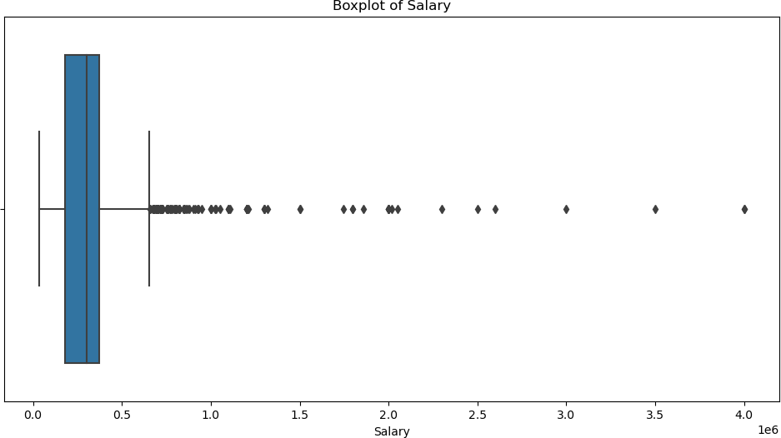

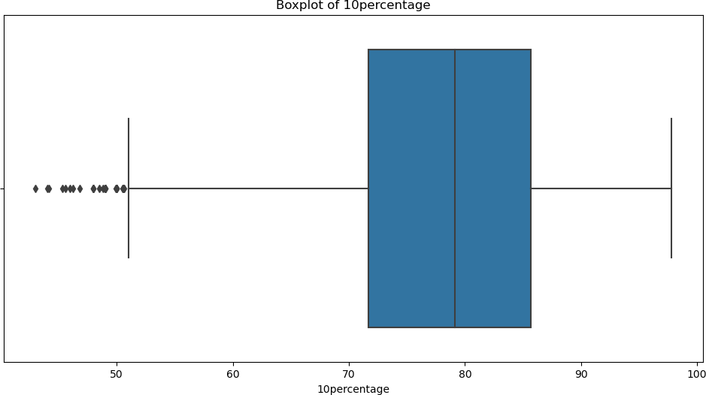

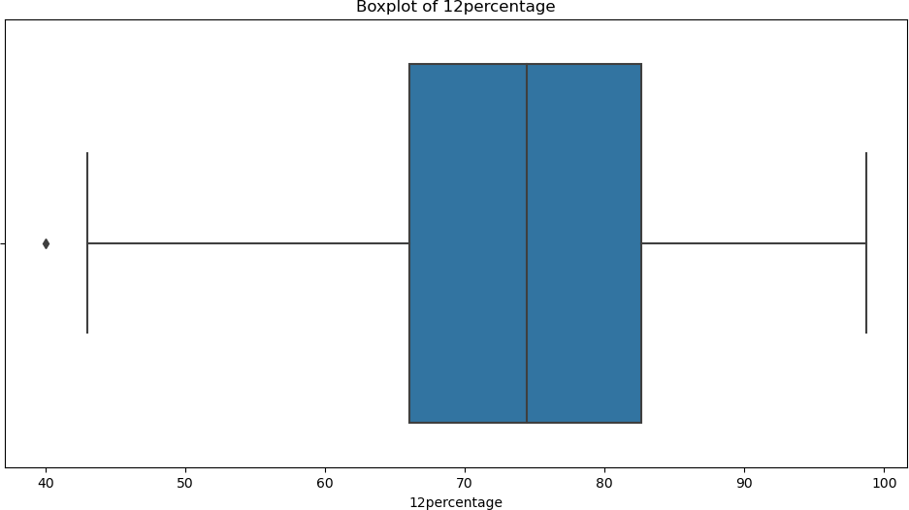

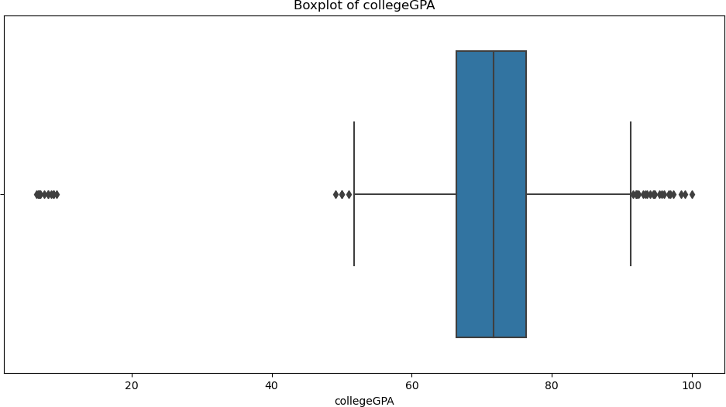

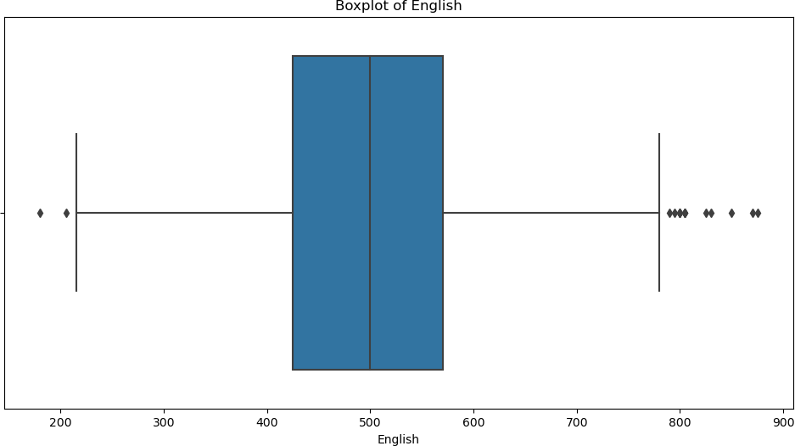

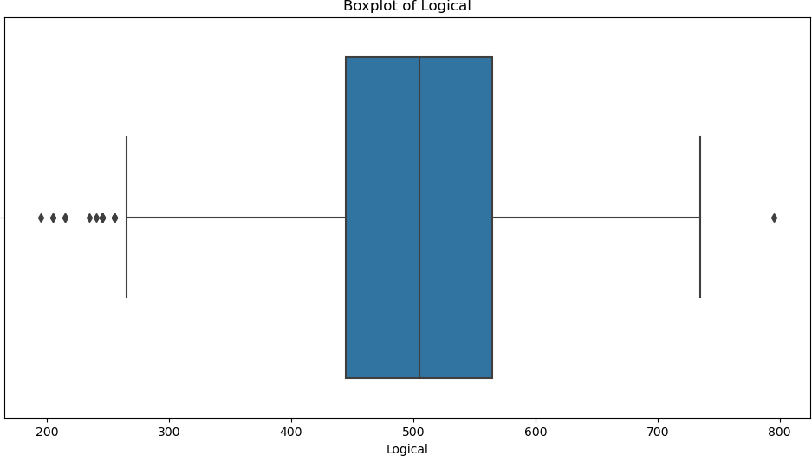

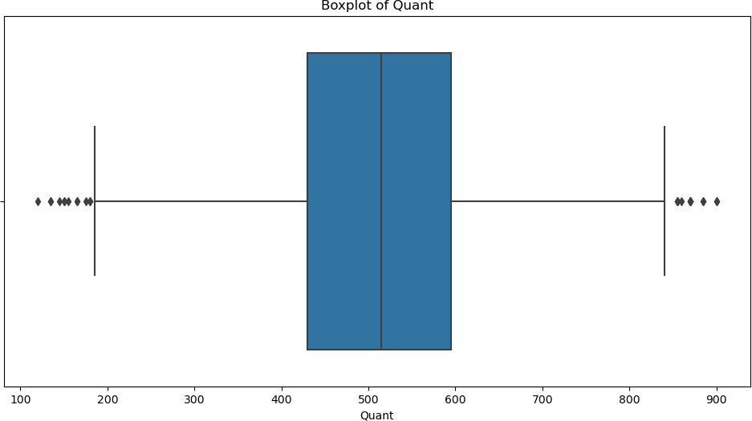

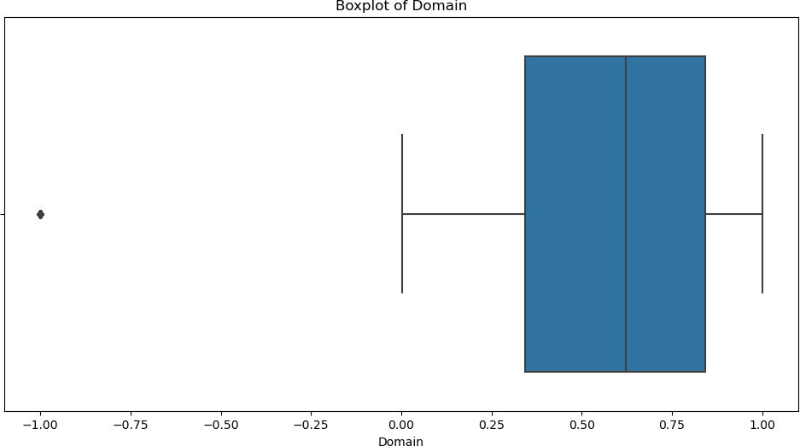

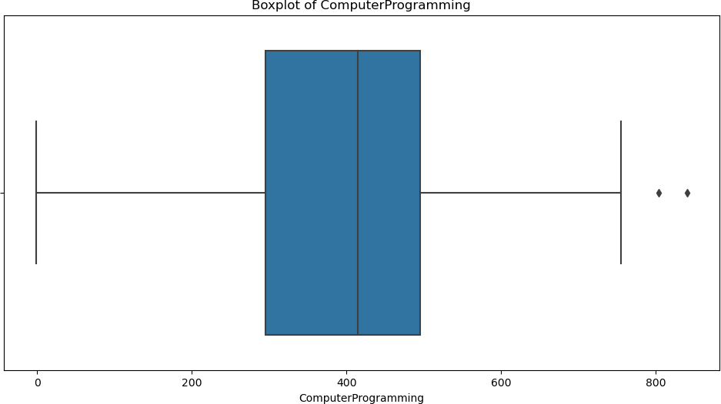

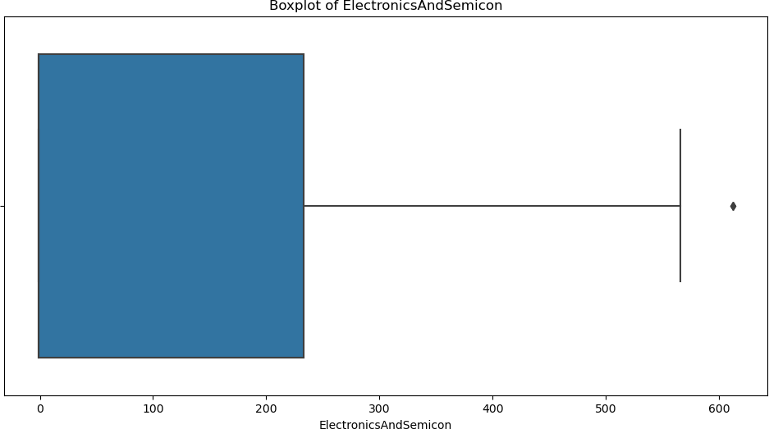

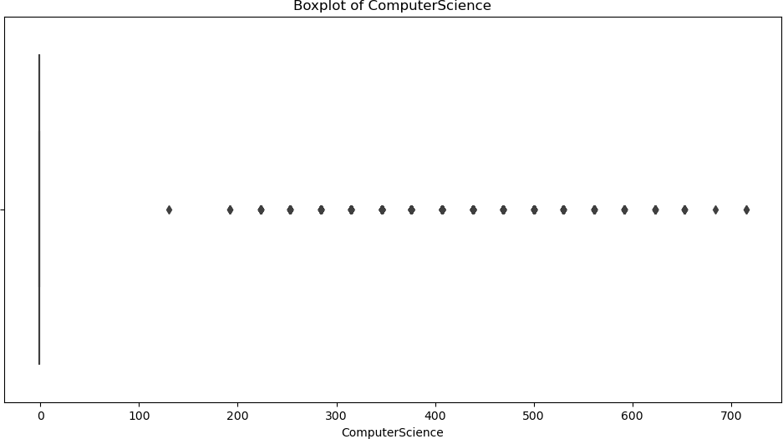

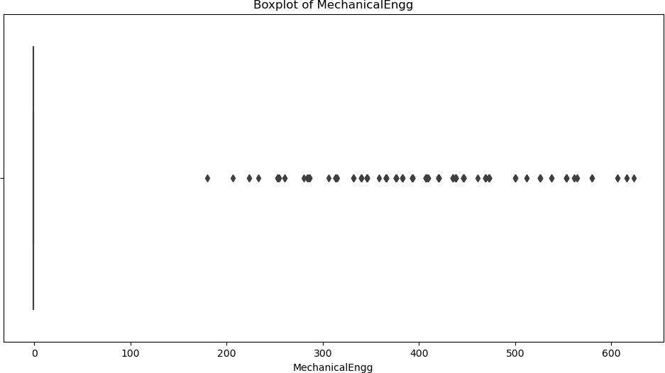

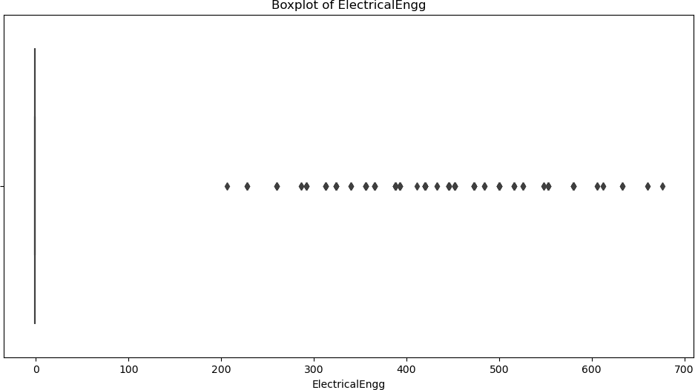

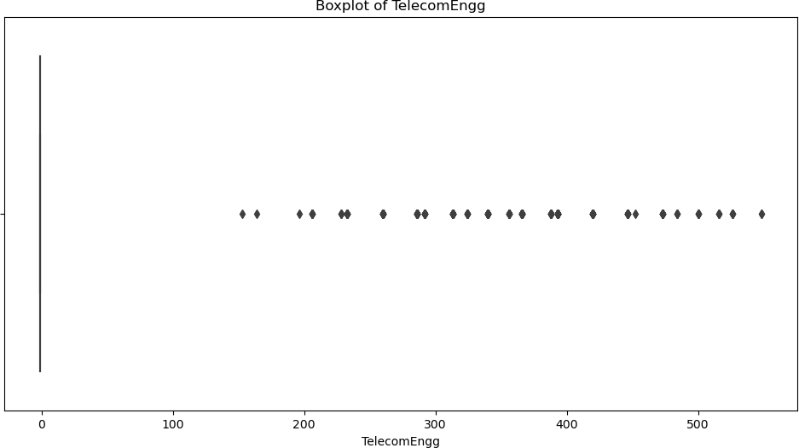

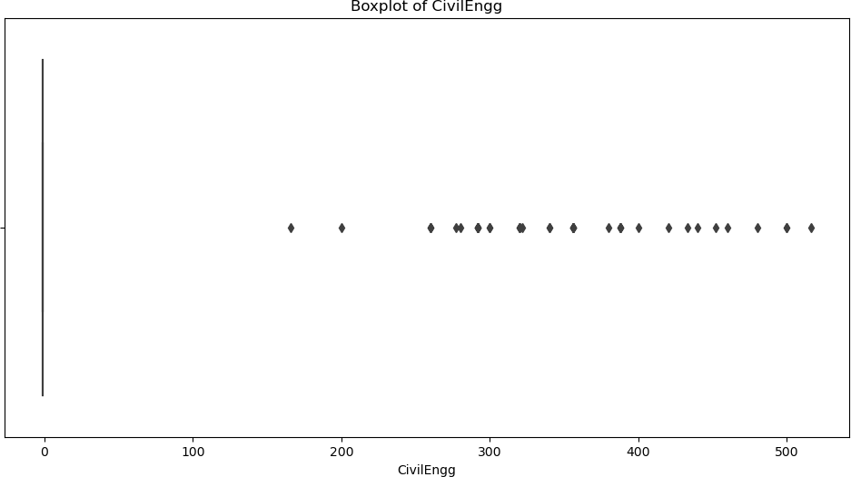

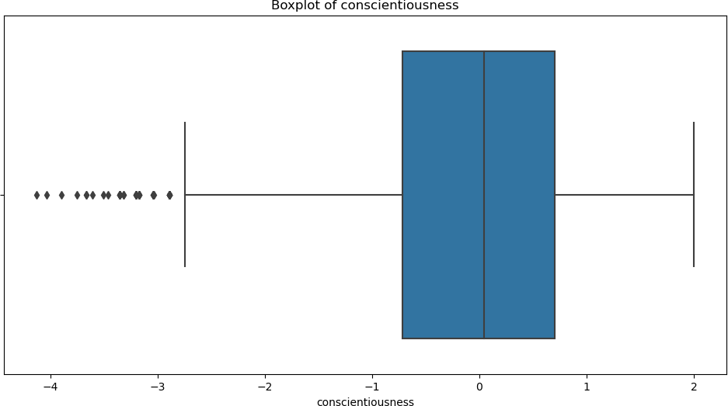

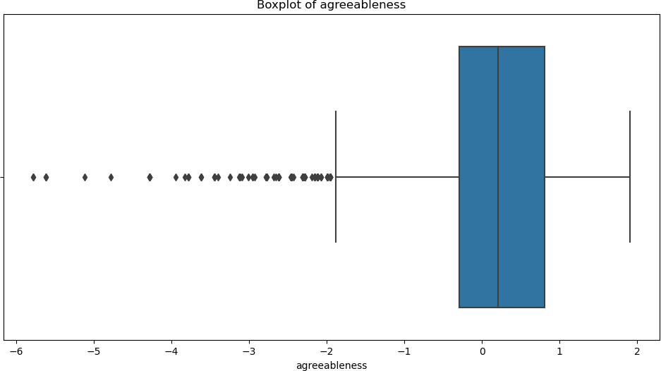

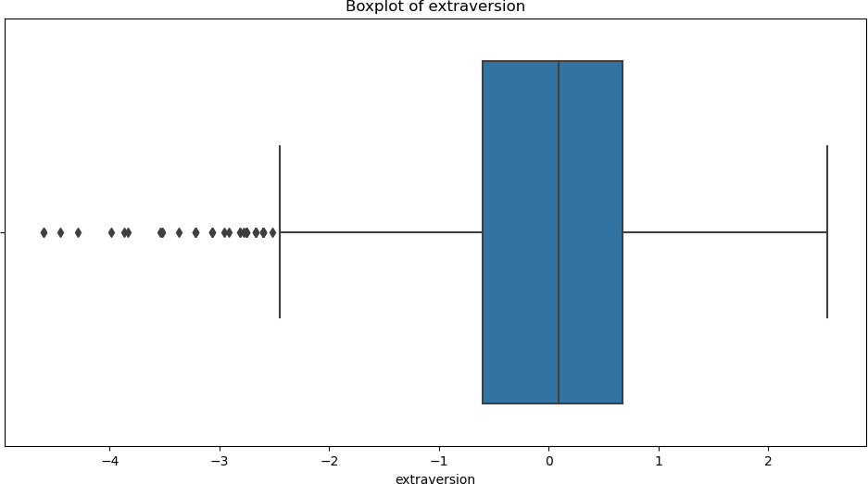

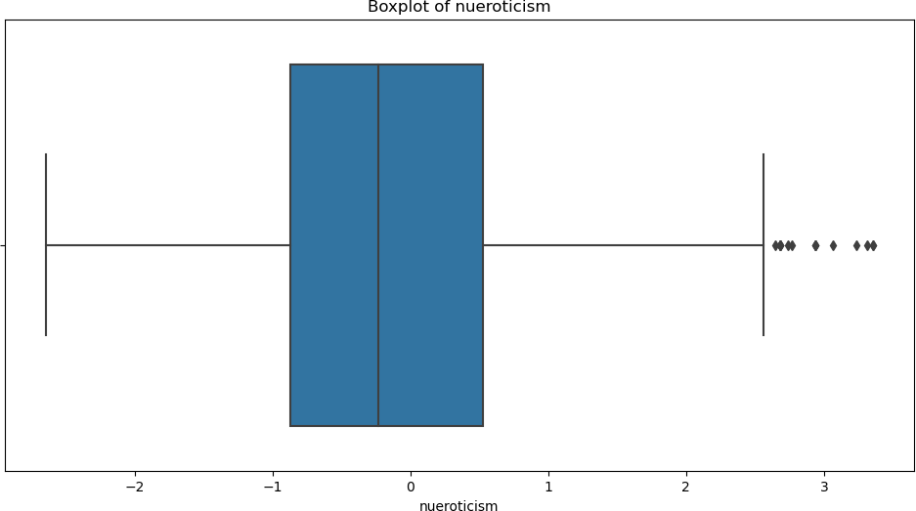

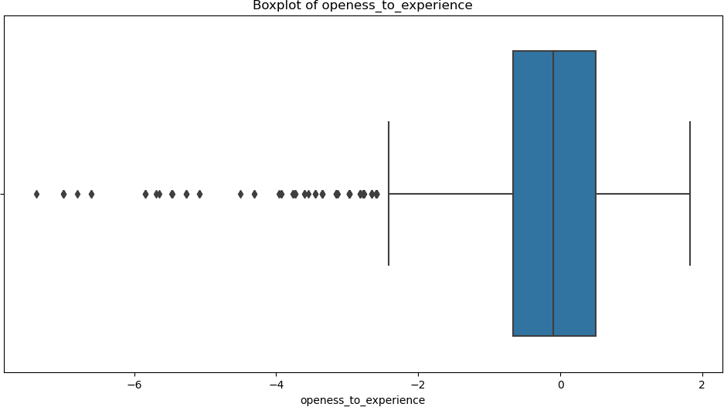

[19]:

*# Outlier Detection*

**for** col **in** numerical_cols:

q1 = df[col].quantile(0.25) q3 = df[col].quantile(0.75) iqr = q3 - q1

lower_bound = q1 - 1.5 * iqr upper_bound = q3 + 1.5 * iqr

outliers = df[(df[col] < lower_bound) | (df[col] > upper_bound)] print(f'Outliers in **{**col**}**: **{**len(outliers)**}**')

[20]:

Outliers in Salary: 109 Outliers in 10percentage: 30 Outliers in 12percentage: 1 Outliers in collegeGPA: 38 Outliers in English: 15 Outliers in Logical: 18 Outliers in Quant: 25 Outliers in Domain: 246

Outliers in ComputerProgramming: 2 Outliers in ElectronicsAndSemicon: 2 Outliers in ComputerScience: 902 Outliers in MechanicalEngg: 235 Outliers in ElectricalEngg: 161 Outliers in TelecomEngg: 374 Outliers in CivilEngg: 42

Outliers in conscientiousness: 39 Outliers in agreeableness: 123 Outliers in extraversion: 40 Outliers in nueroticism: 15

Outliers in openess_to_experience: 95

## Outlier Treatment

**Filtering the data so that there would be consistency in the data**

df=df.loc[(df["Domain"]>-1)] df.shape

[20]: (3752, 39)

[21]:

df=df.loc[(df["MechanicalEngg"]< 200)] df.shape

[21]: (3521, 39)

[22]:

df=df.loc[(df["ElectricalEngg"]< 200)] df.shape

[22]: (3363, 39)

[23]:

df=df.loc[(df["TelecomEngg"]< 100)] df.shape

[23]: (2995, 39)

[24]:

df=df.loc[(df["agreeableness"]> -1.5)] df.shape

[24]: (2853, 39)

[25]:

df=df.loc[(df["openess_to_experience"]> -1.5)] df.shape

[25]: (2709, 39)

## Frequency Distribution

[26]:

**for** column **in** numerical_cols:

plt.figure(figsize=(15,9)) sns.histplot(df[column], kde=**True**) plt.title(f'Histogram for **{**column**}**') plt.show()

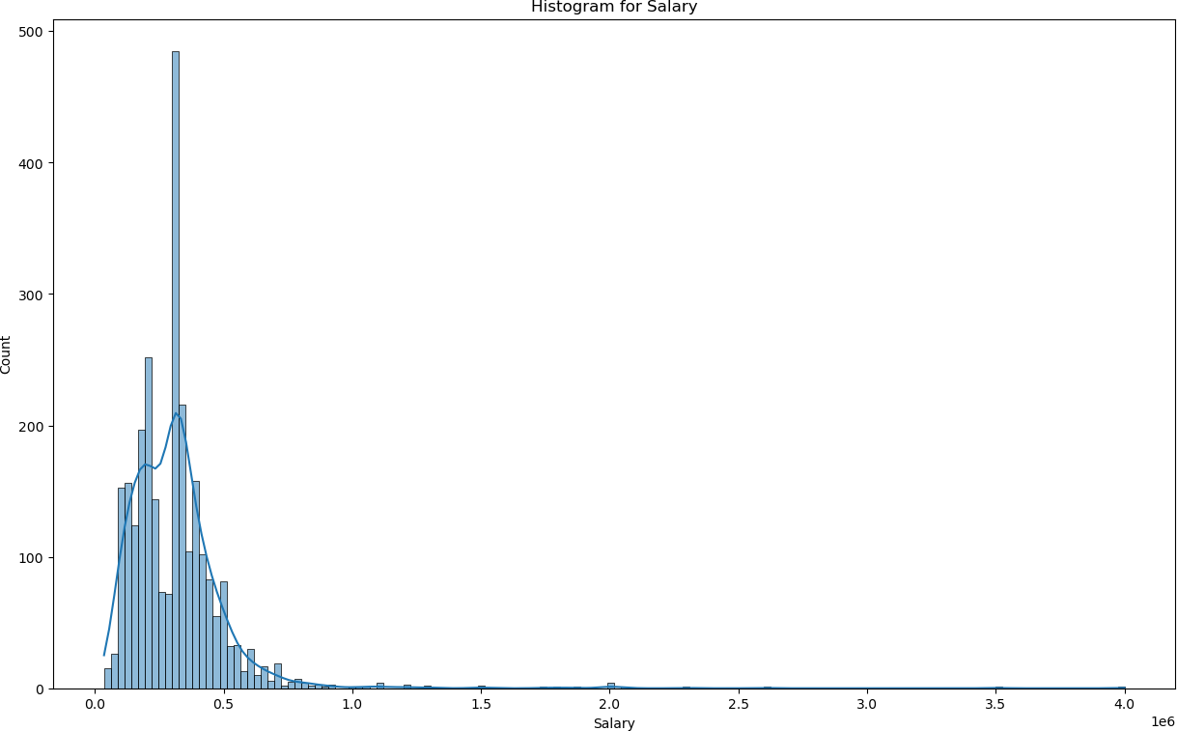

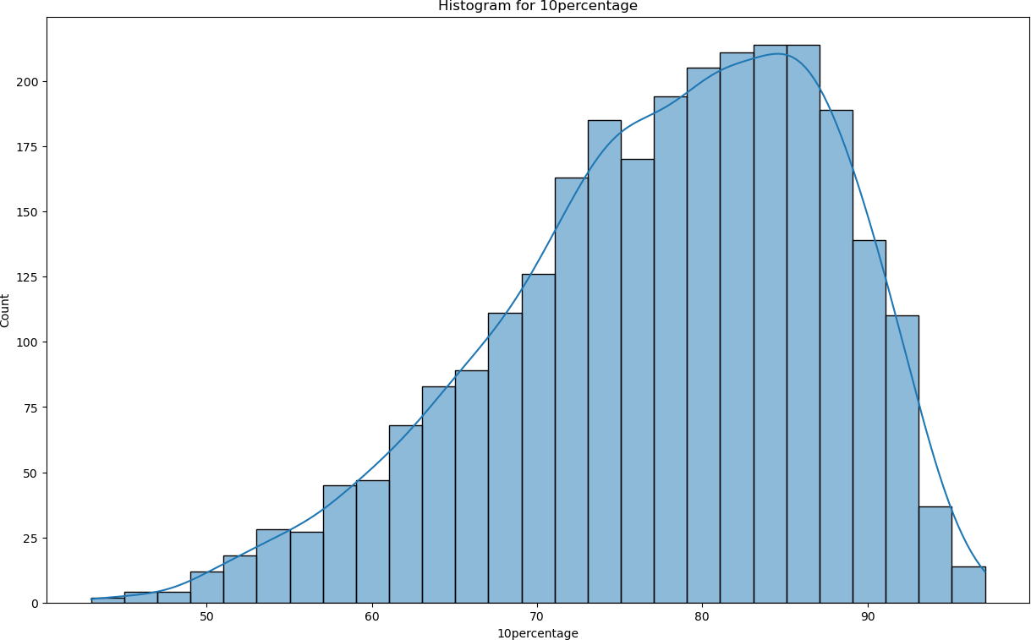

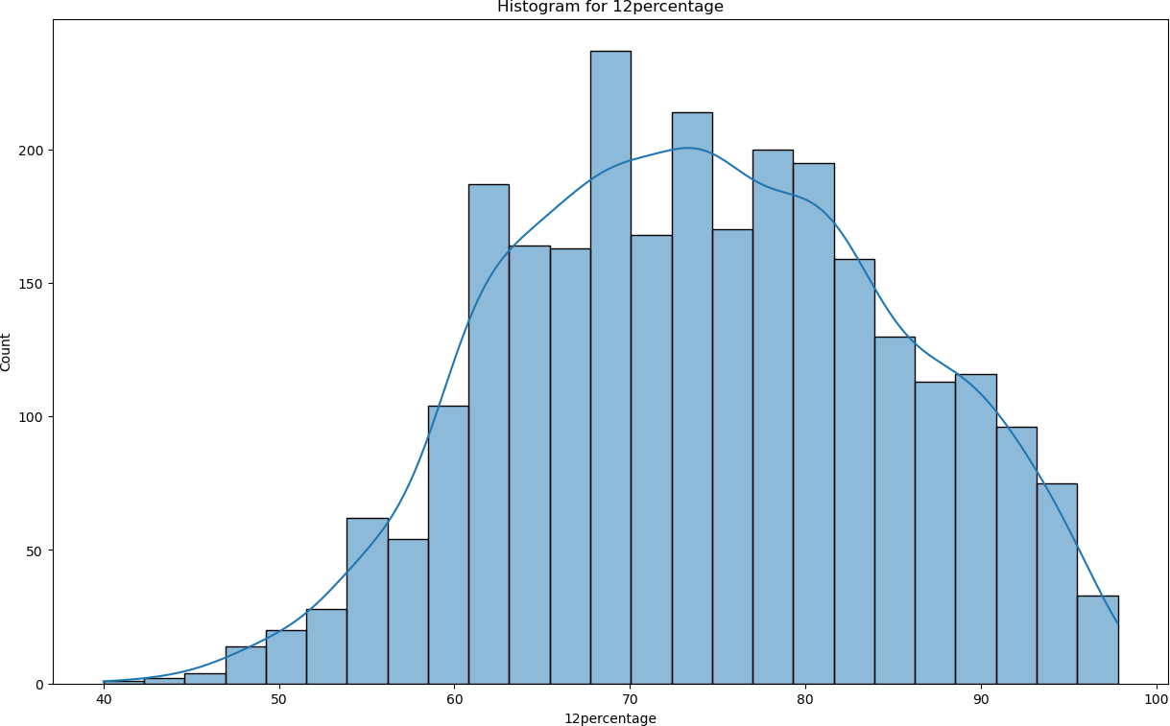

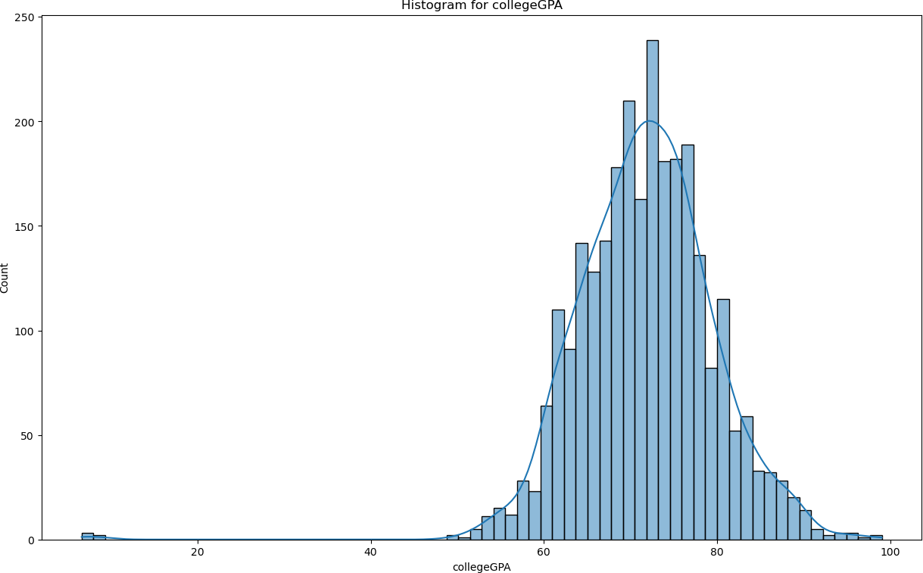

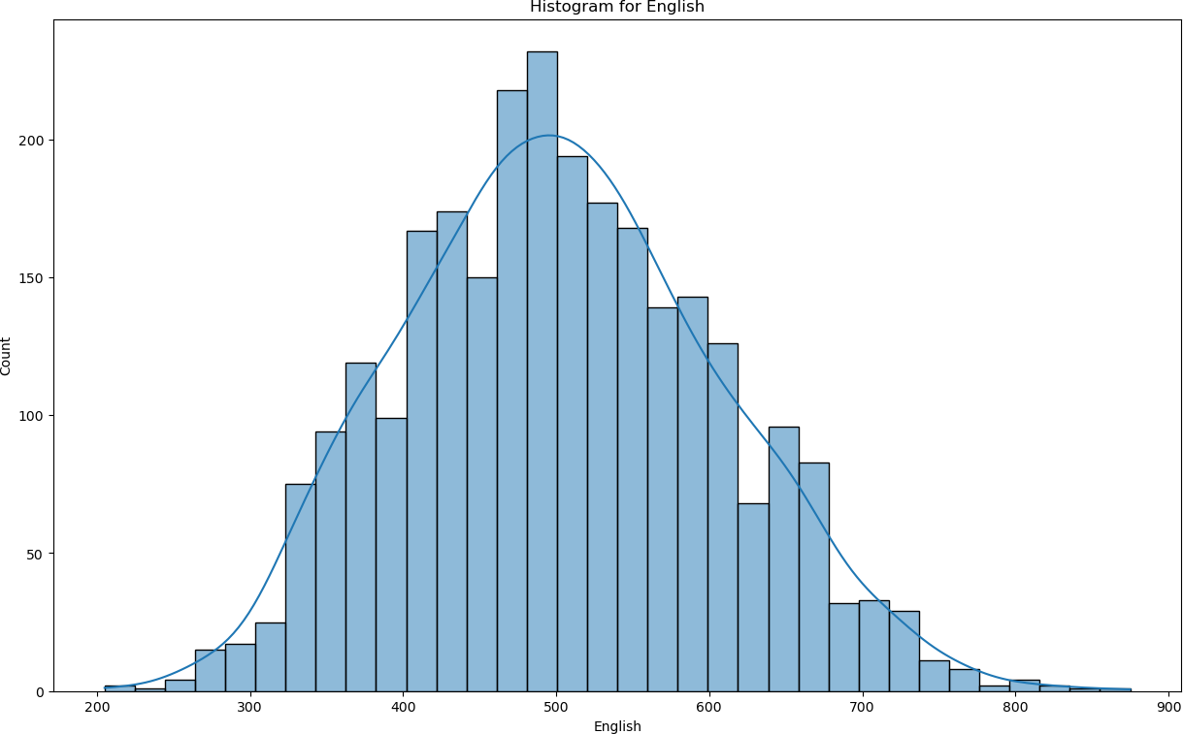

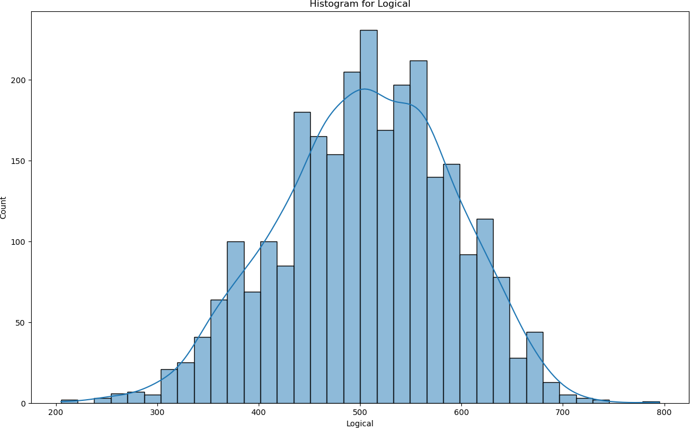

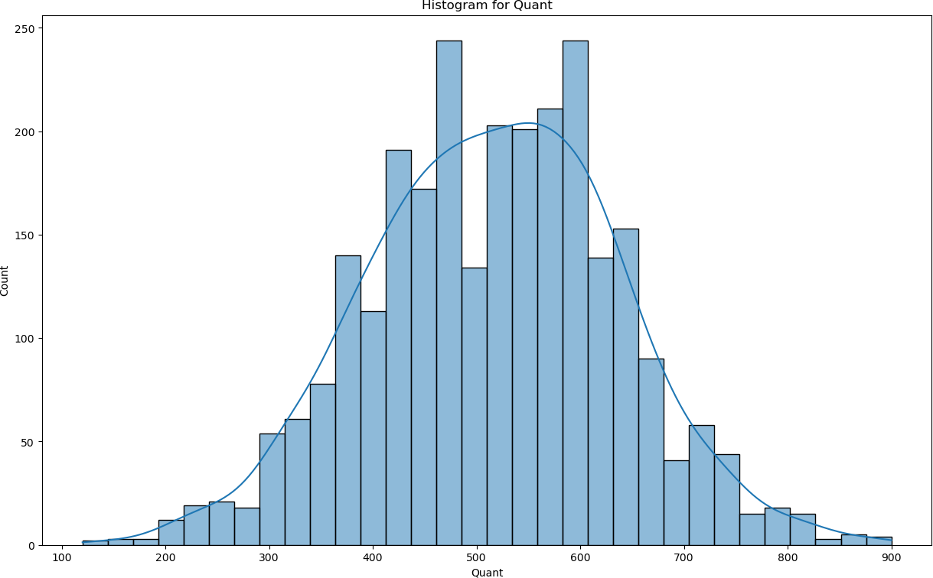

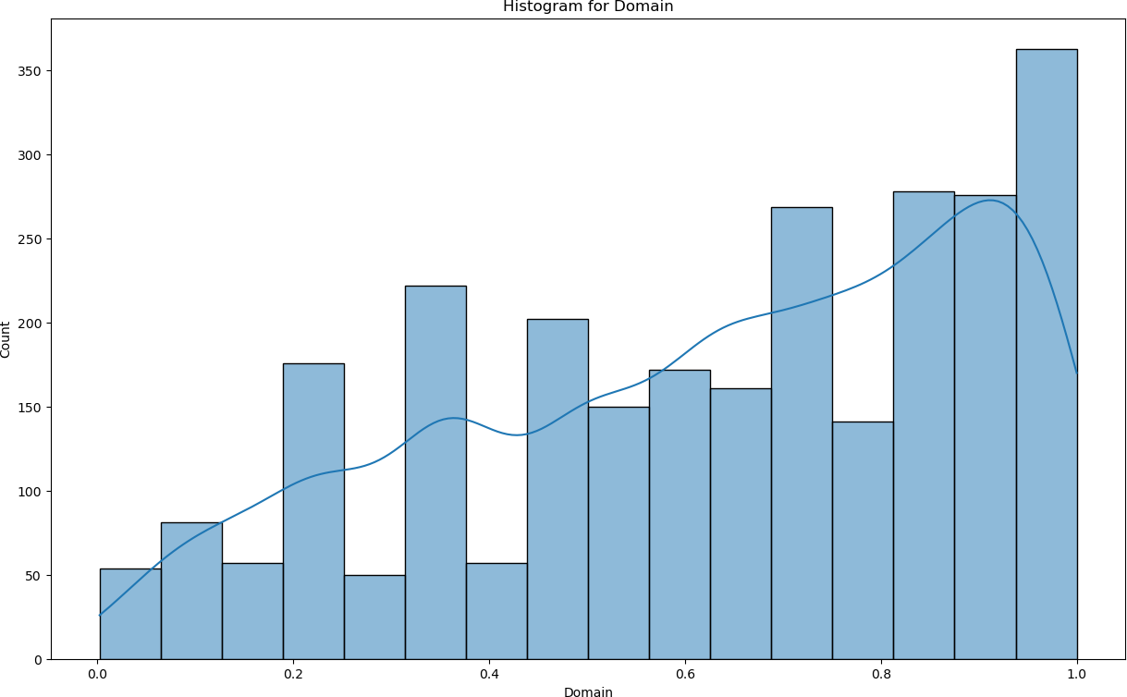

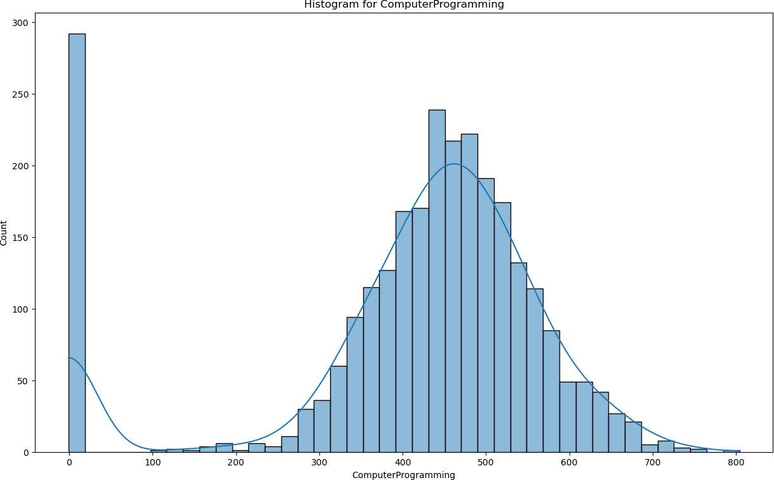

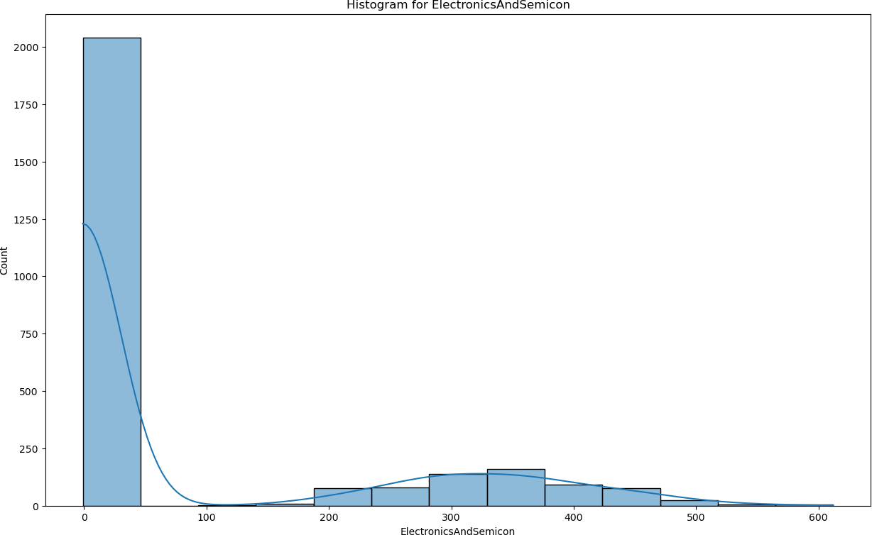

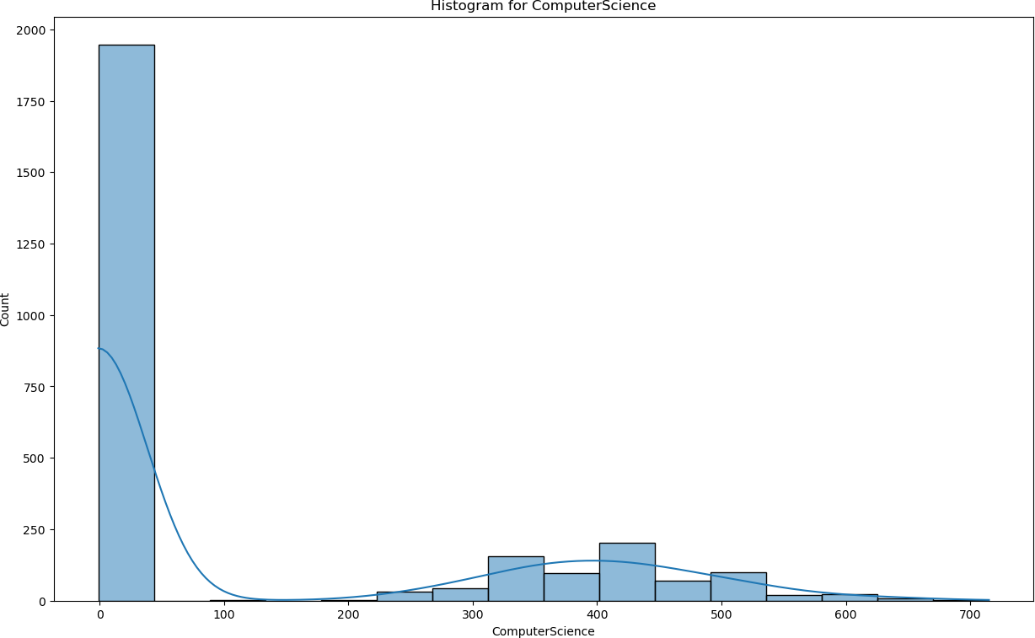

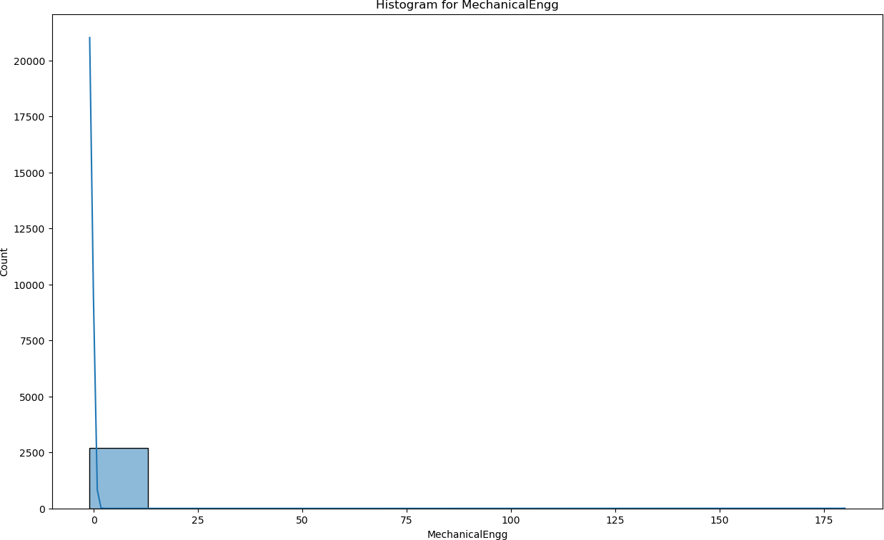

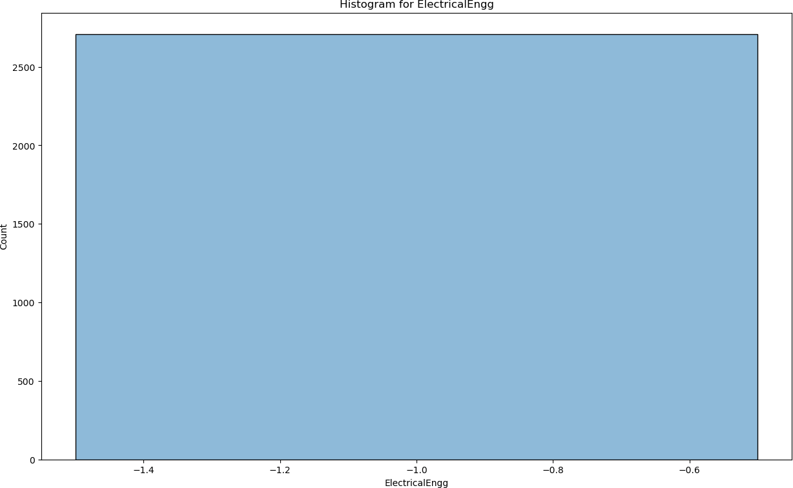

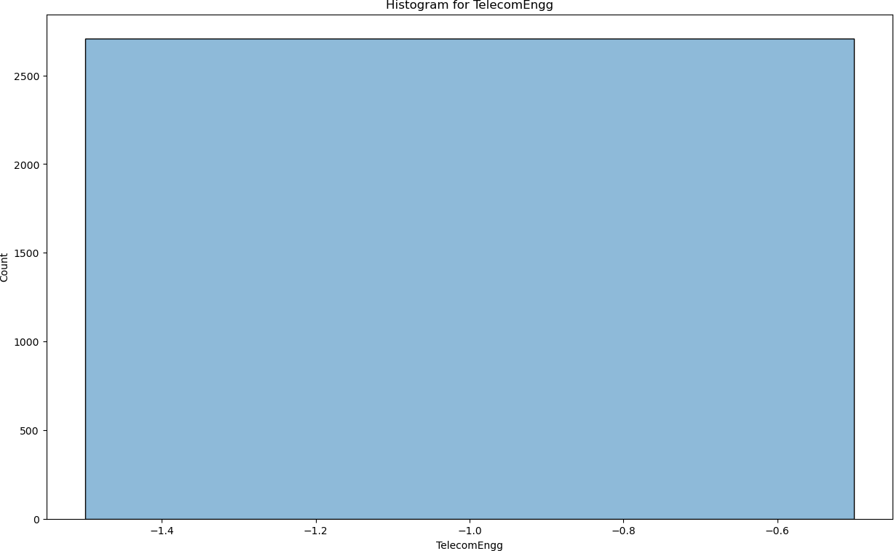

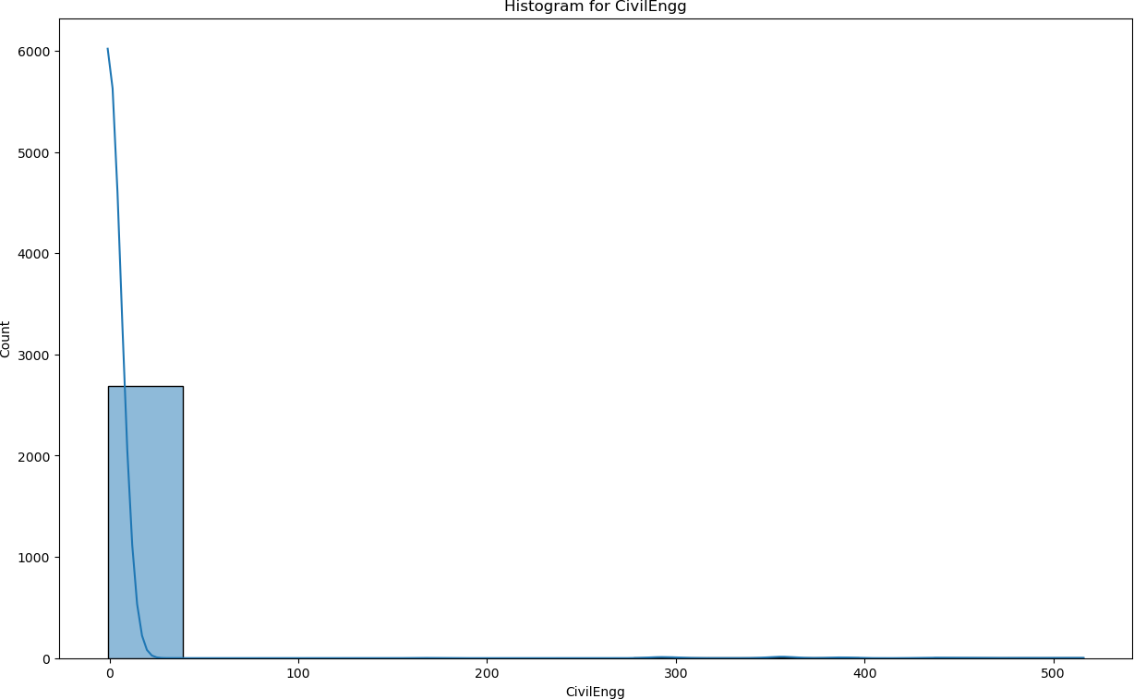

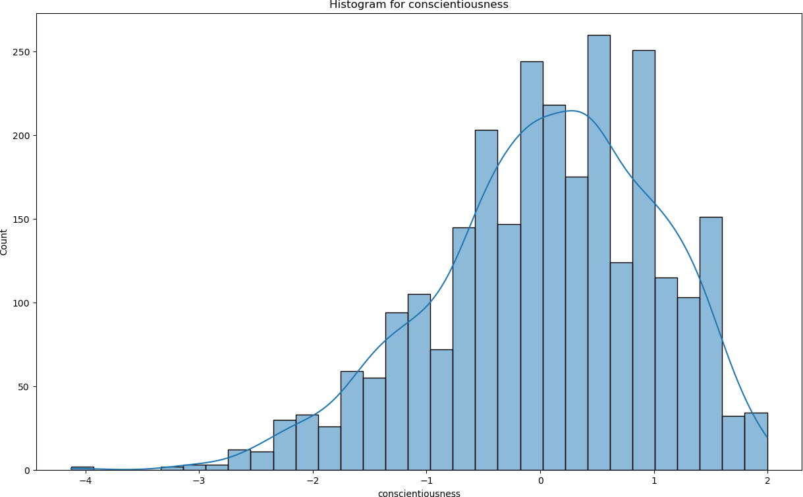

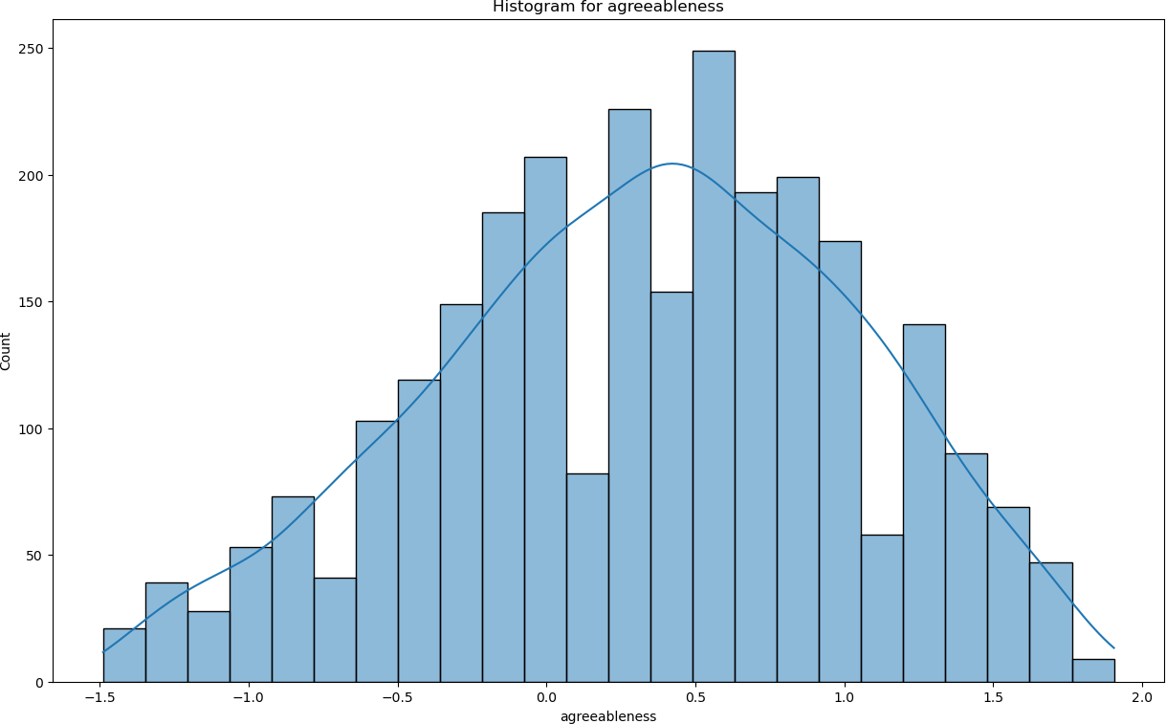

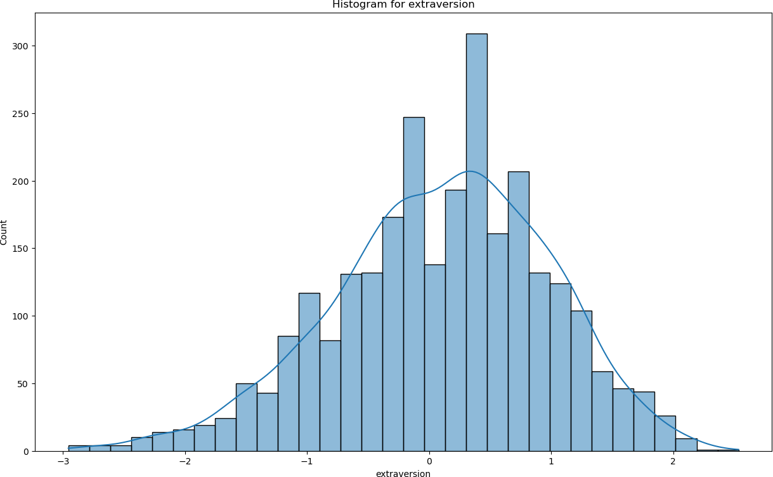

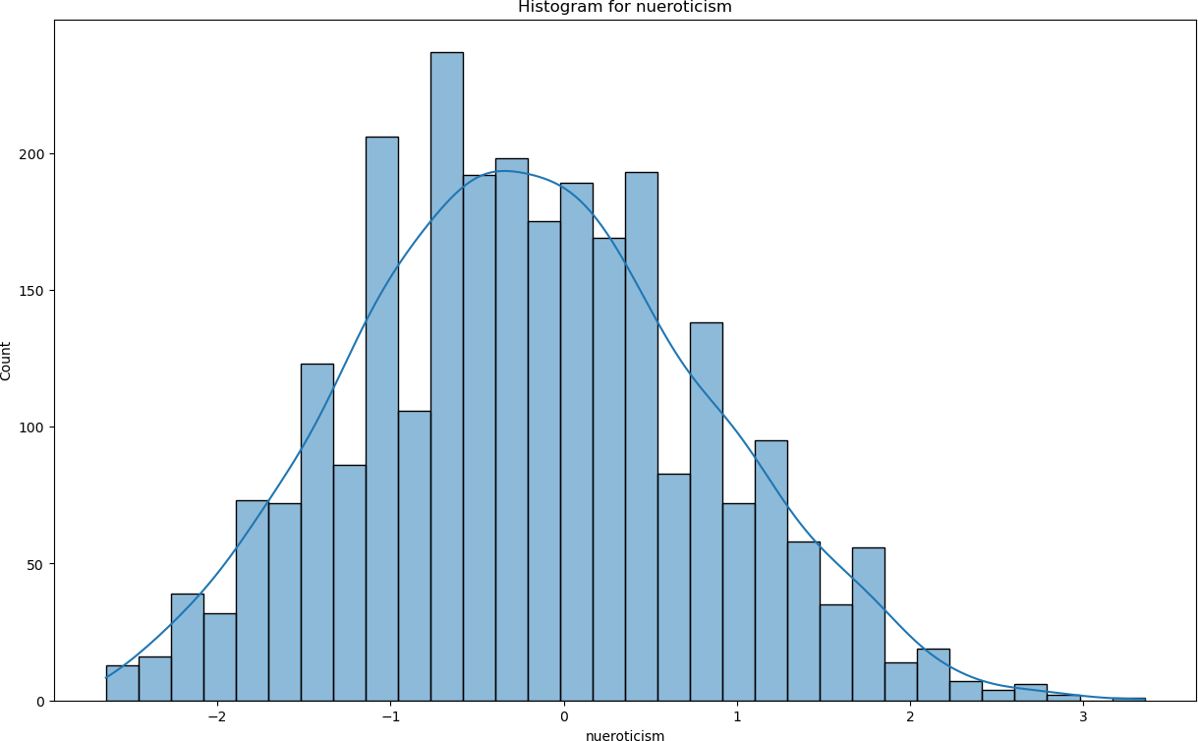

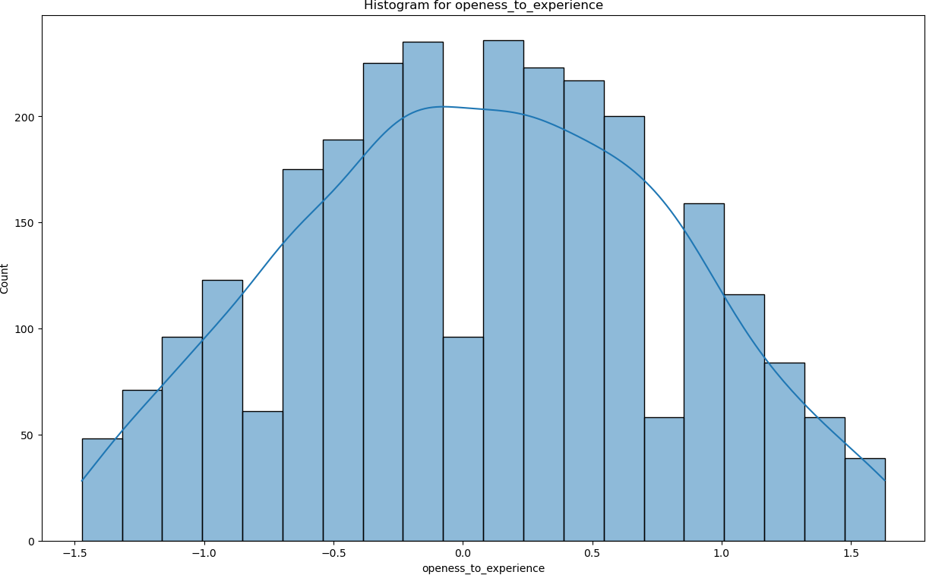

[27]:

## From these visualisations

* + - * Most of the salaries are between 100000 and 1000000.
      * Most of the persons have around 90%. (left skewed distribution)
      * Most number of persons are graduate 12th in between 2007 and 2010
      * The histogram plot of 12percentage is slightly leftskewed (very slight). Most of the person have 70% on their 12th.
      * Most of the students are from tier 2 colleges.
      * Most of the students 70-80 CGPA on their college and they graduated in around 2000s.

# Categorical Variables

*# Frequency Distribution for Categorical Variables*

categorical_cols = ['Designation', 'JobCity', 'Gender', '10board', '12board',␣

↪'CollegeTier', 'Degree', 'Specialization',

'CollegeCityTier', 'CollegeState']

**for** col **in** categorical_cols: plt.figure(figsize=(28,15))

sns.countplot(x=df[col]) plt.title(f'Countplot of **{**col**}**') plt.xticks(rotation=90)

plt.tight_layout()

plt.show()

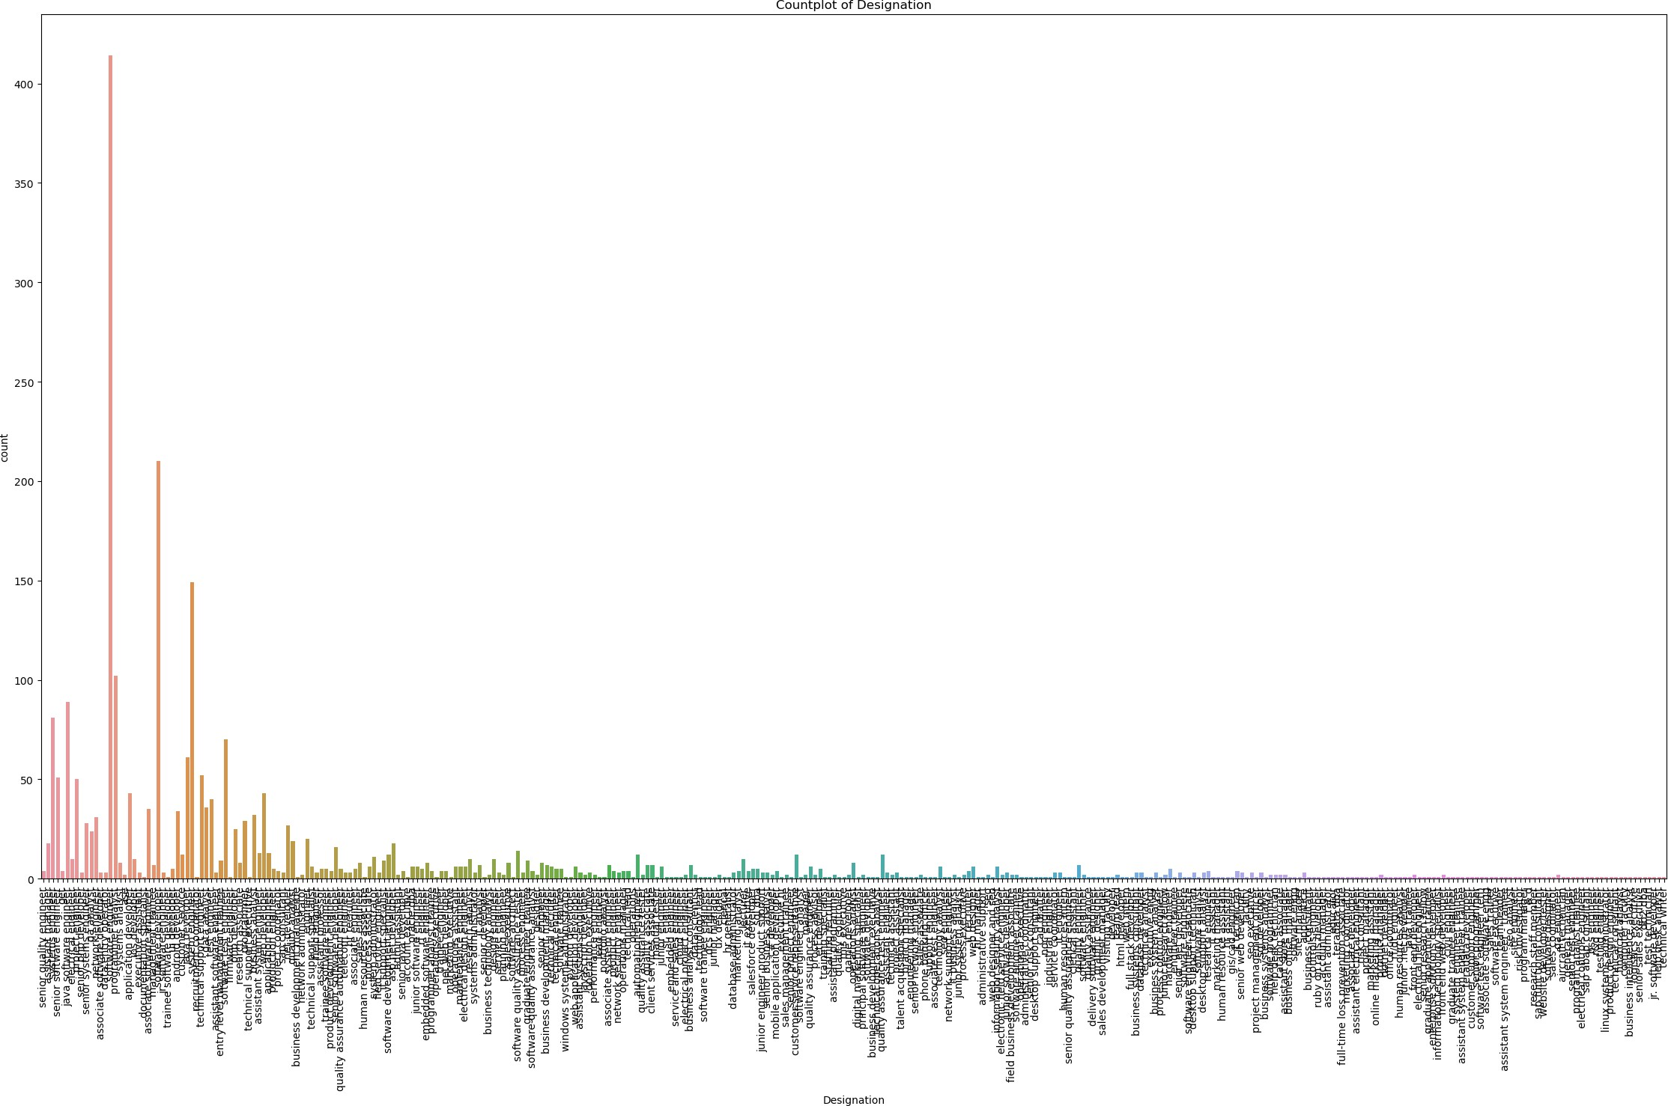

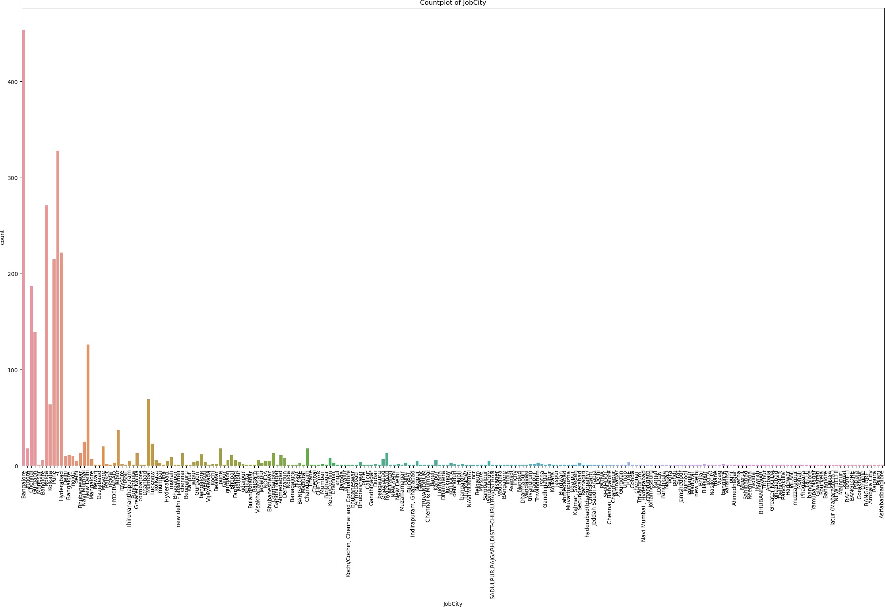

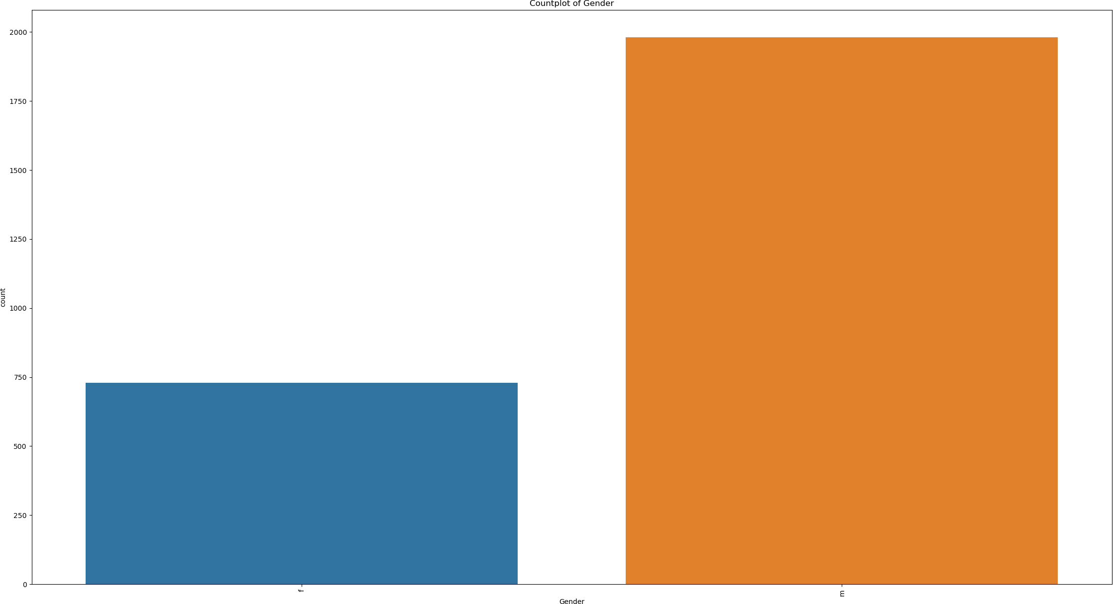

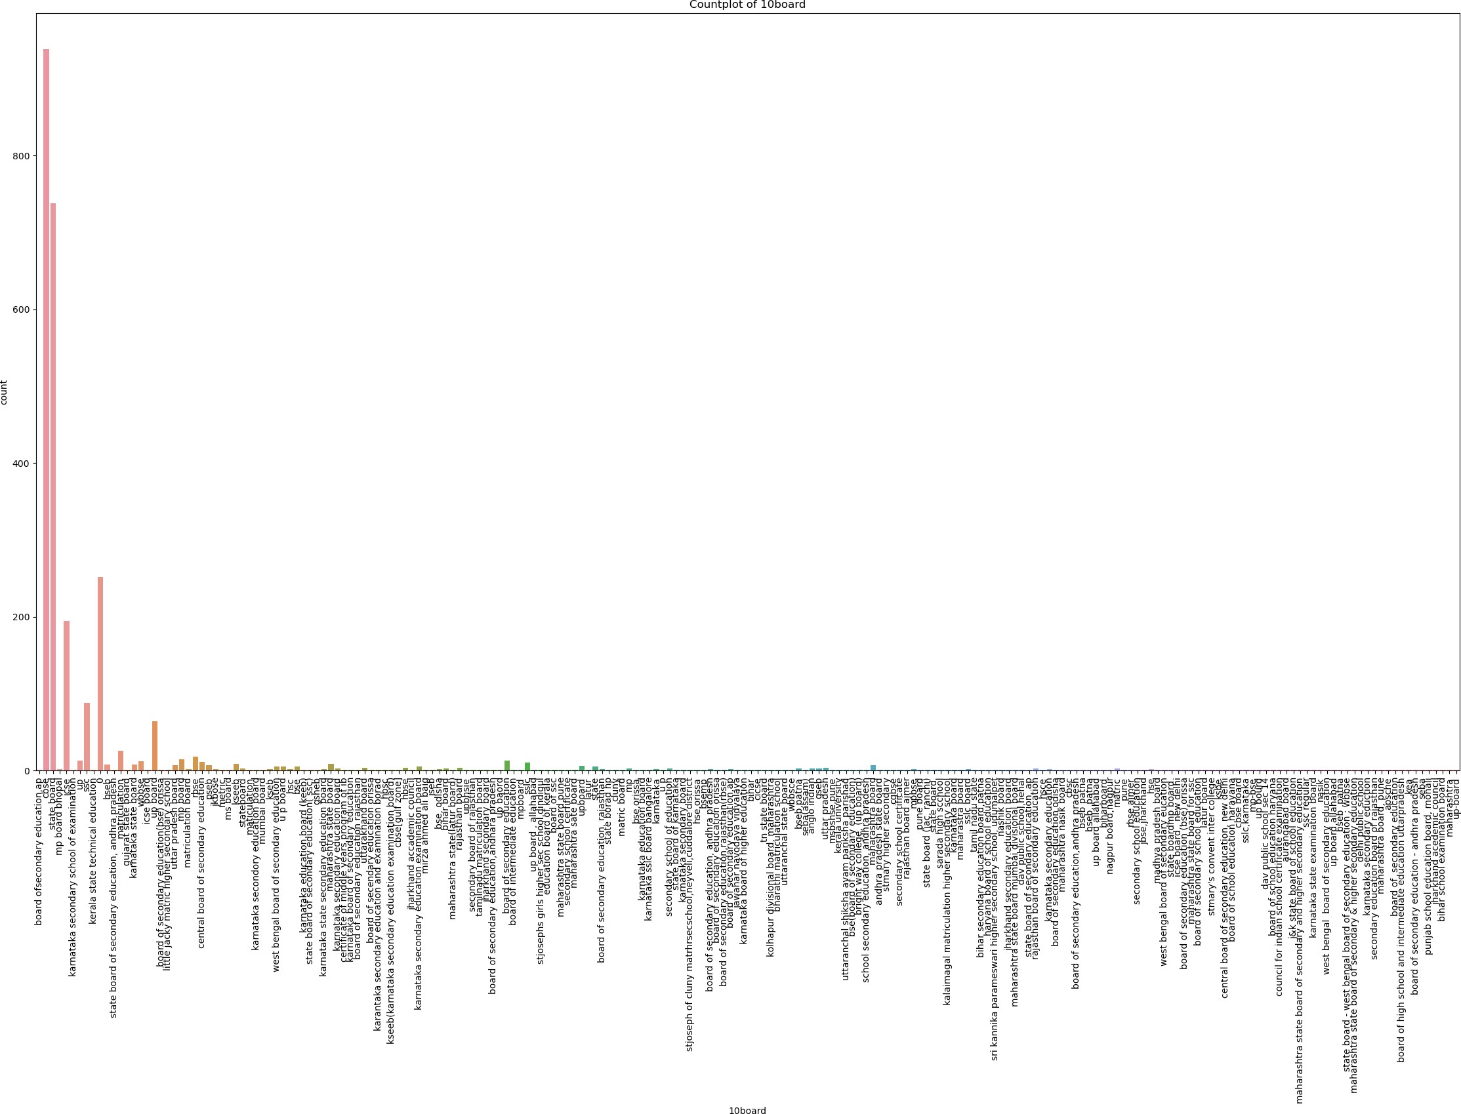

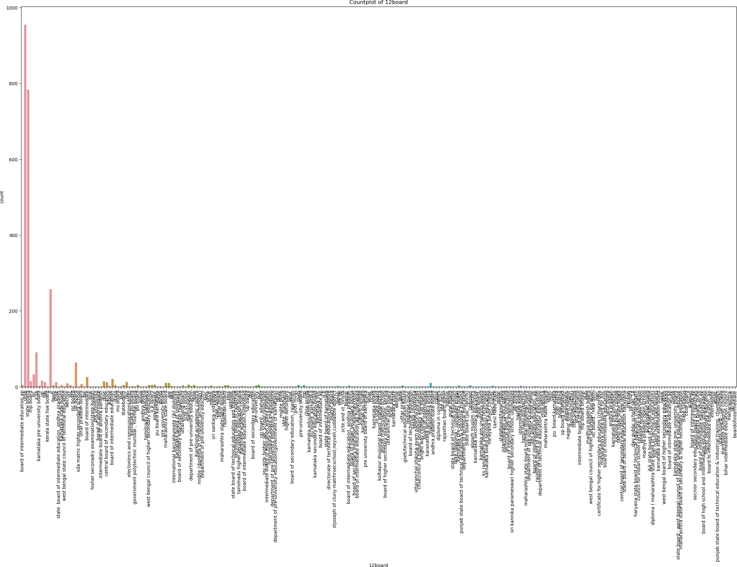

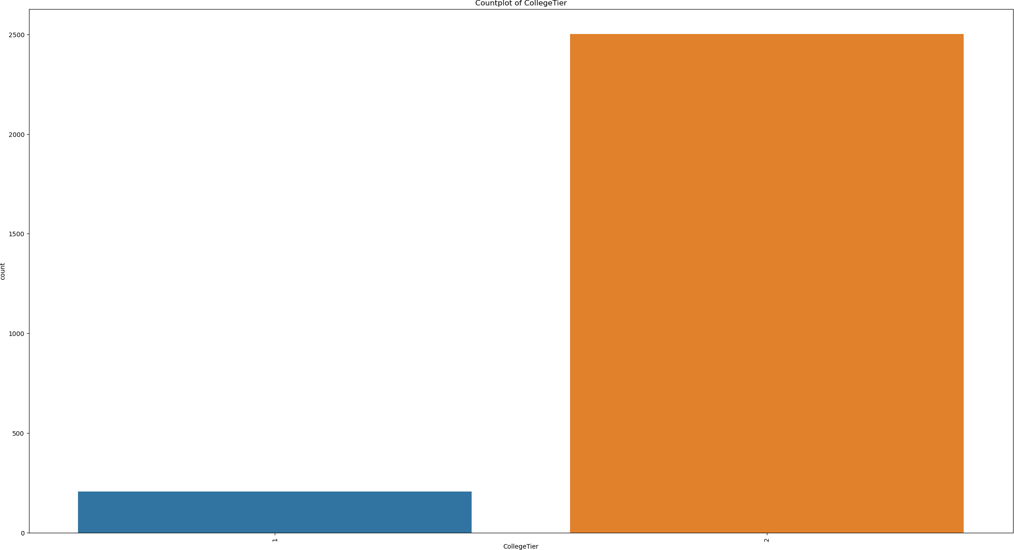

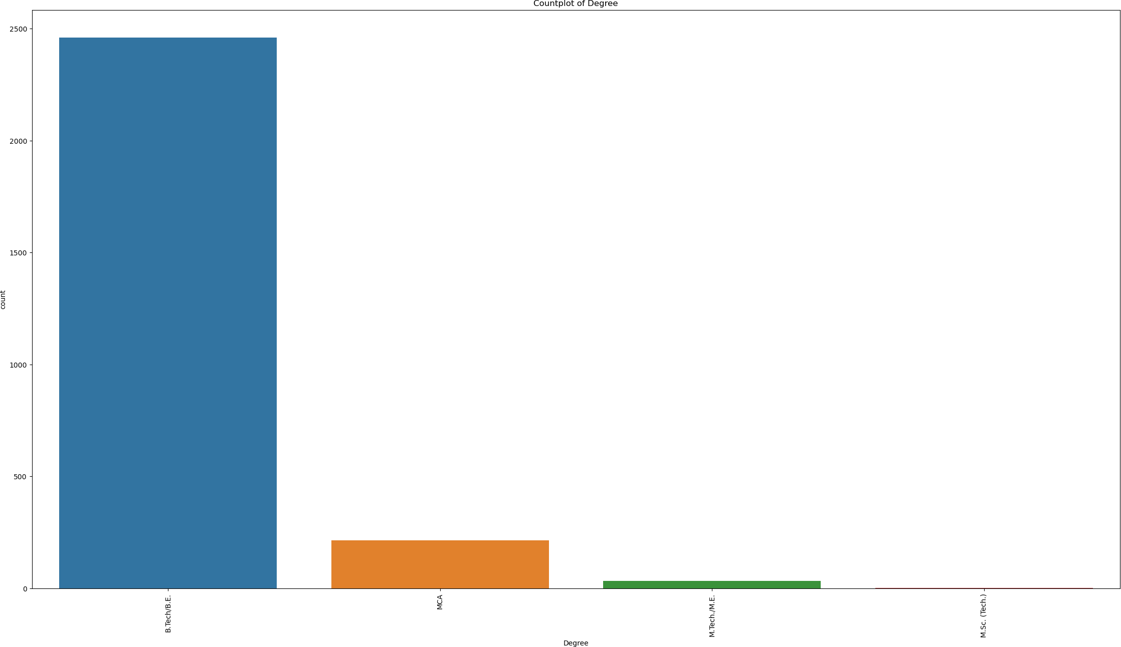

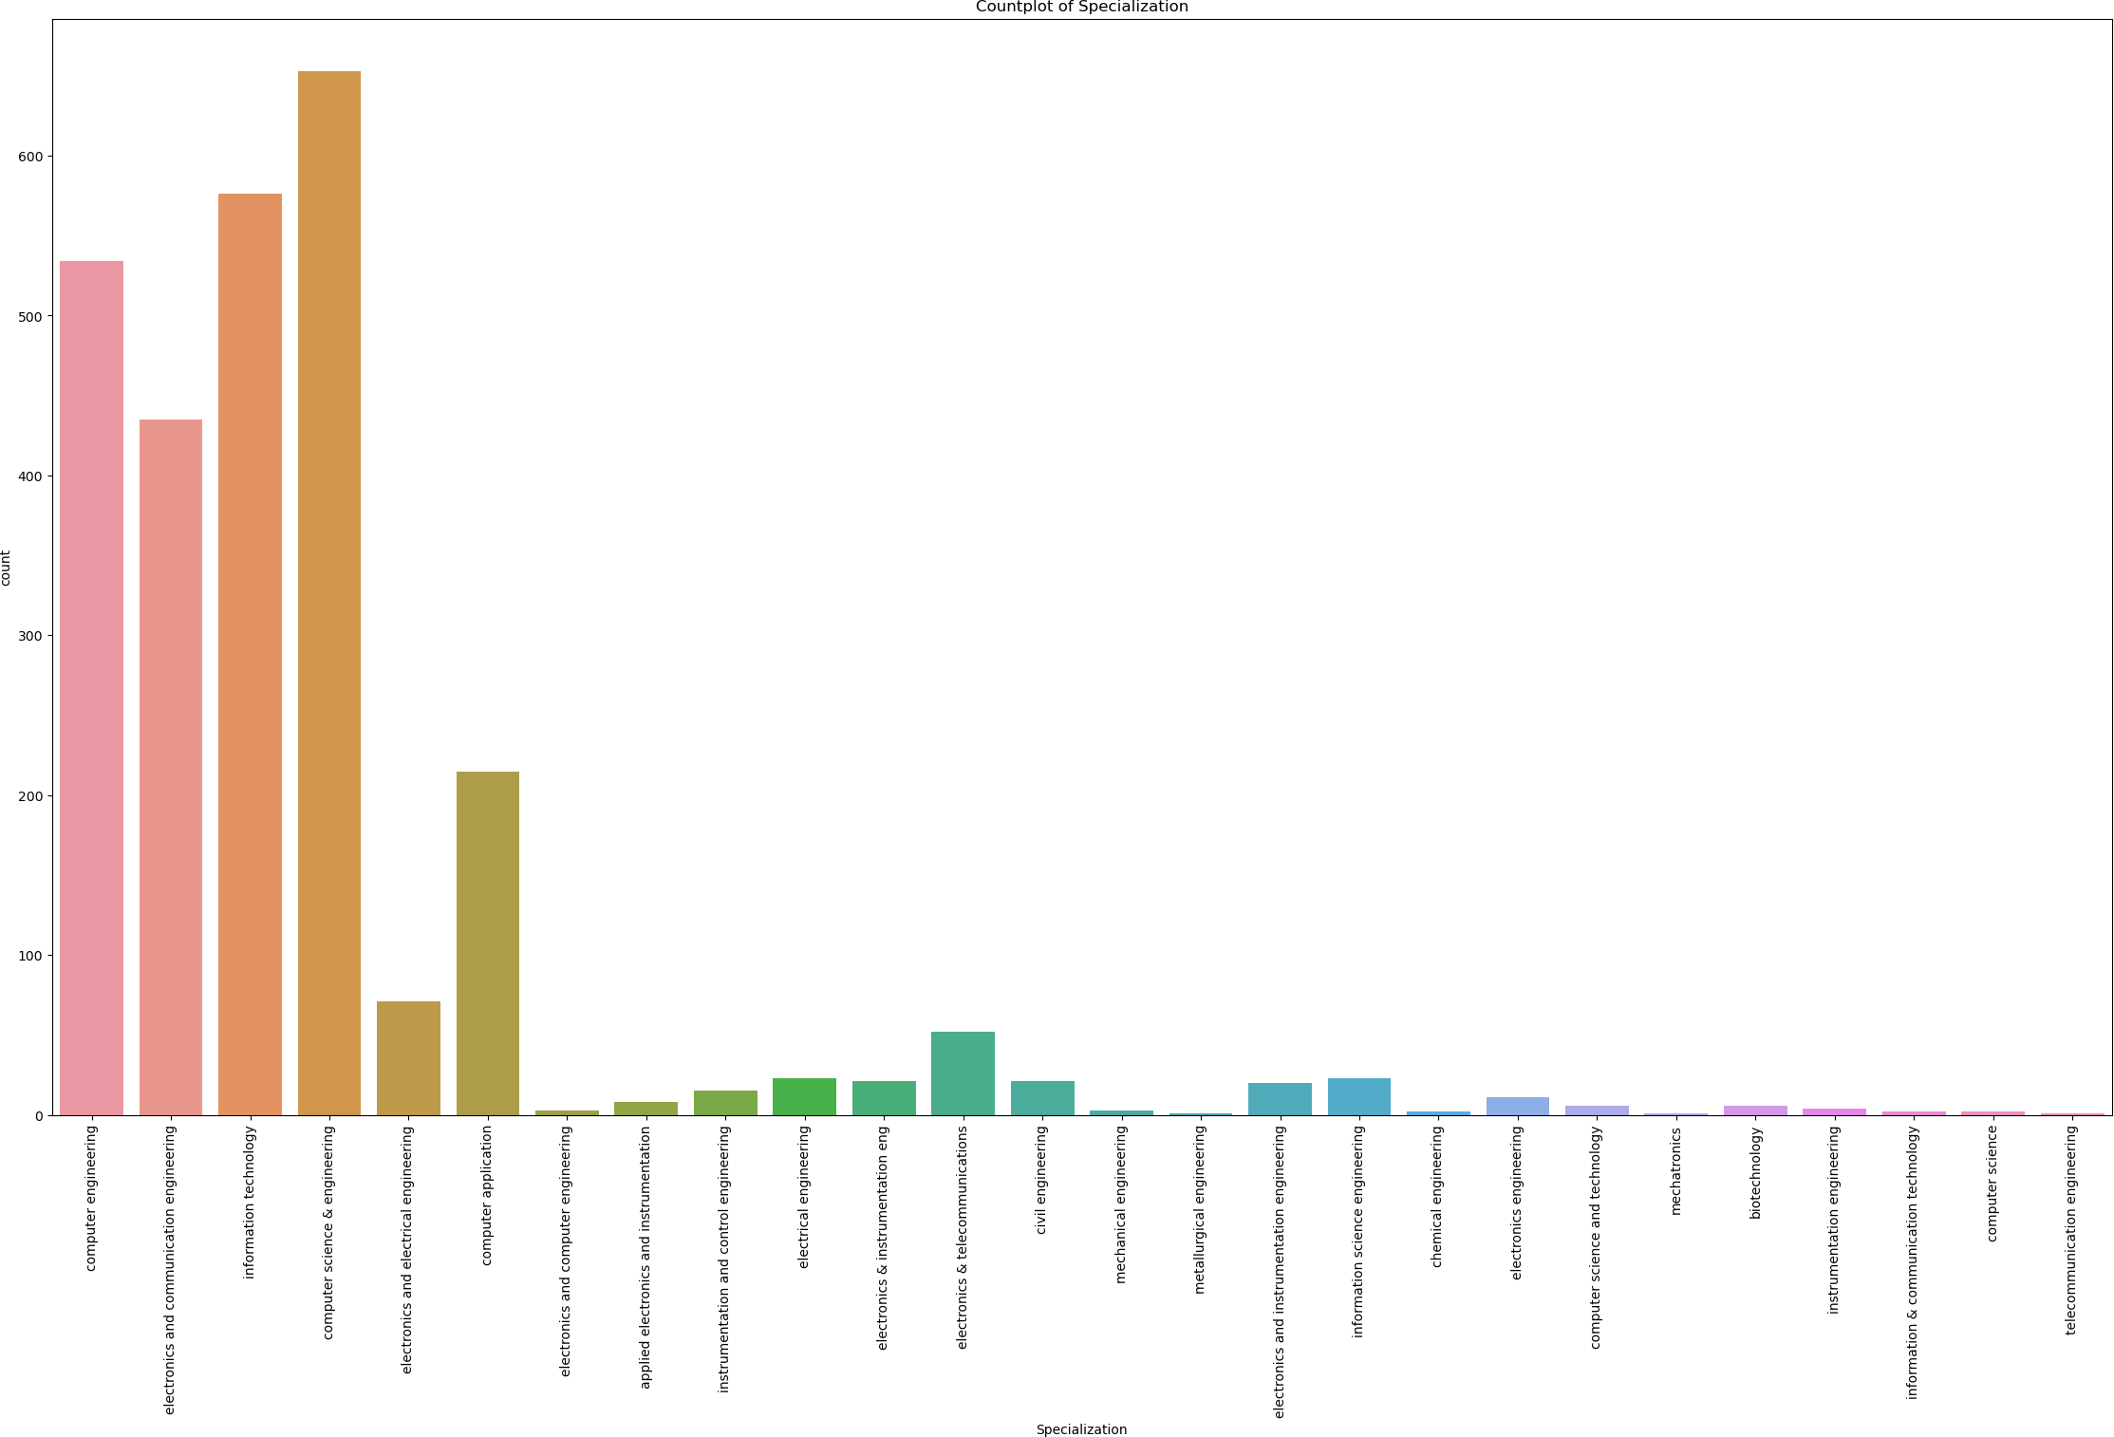

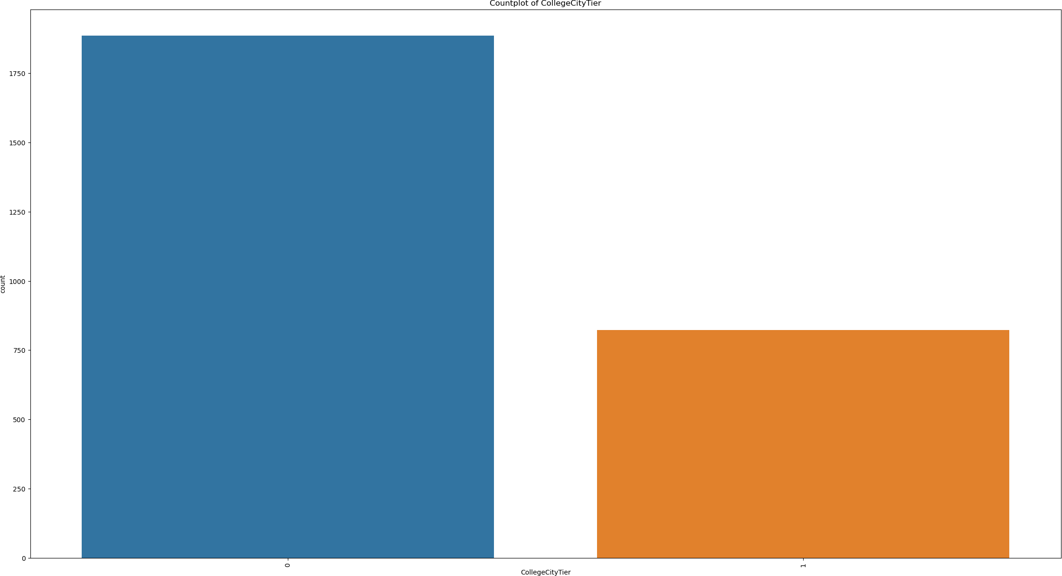

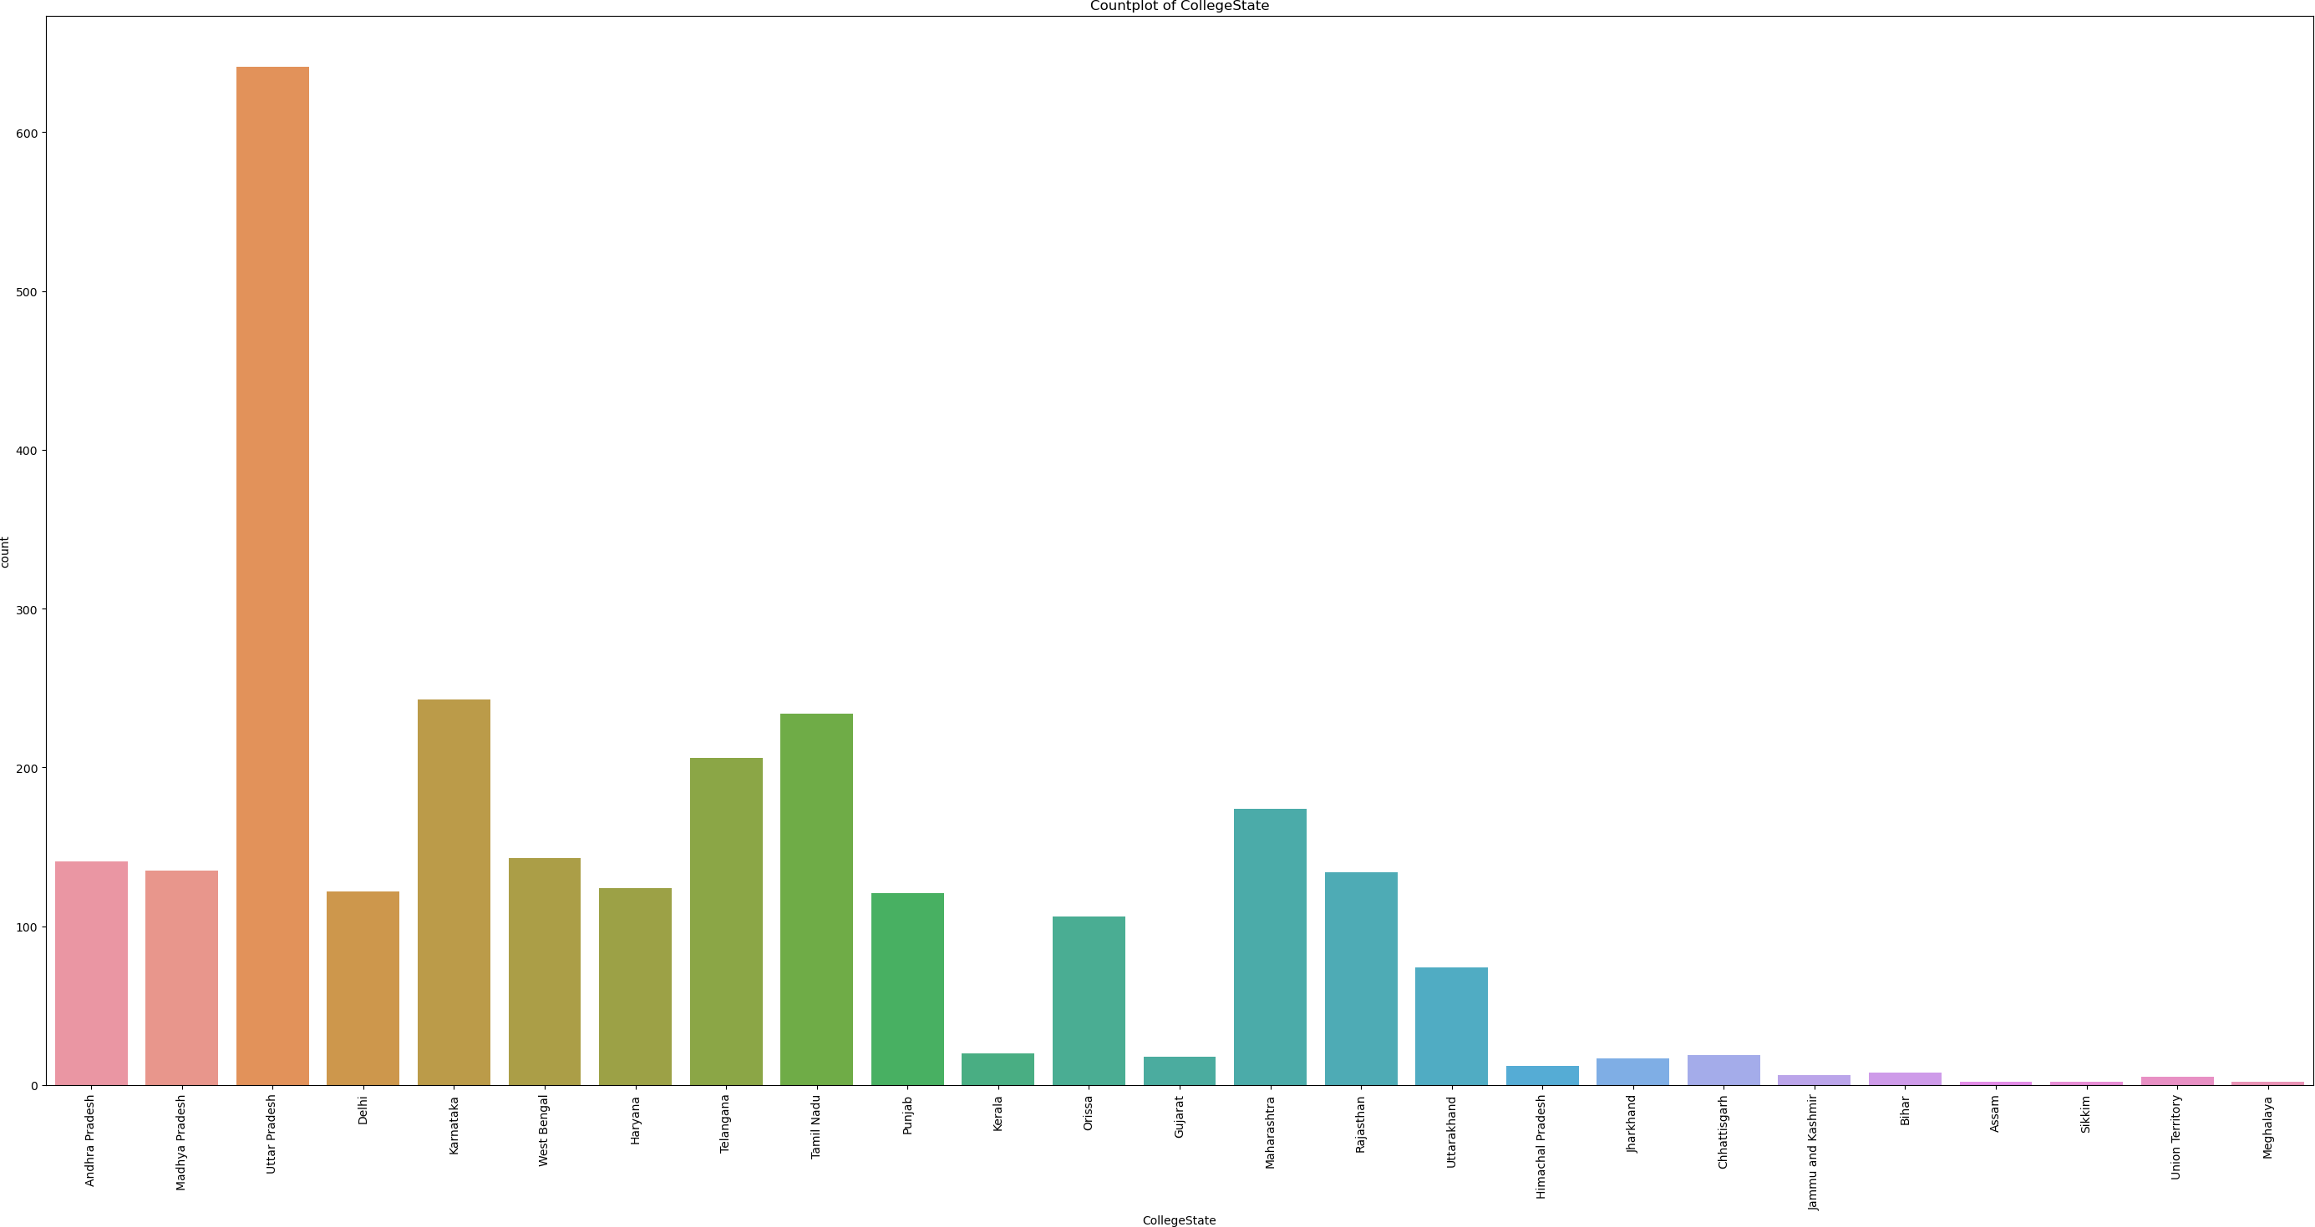

[28]:

# Step 4 - Bivariate Visual and Non Visual Analysis

[28]: Index(['Unnamed: 0', 'ID', 'Salary', 'DOJ', 'DOL', 'Designation', 'JobCity', 'Gender', 'DOB', '10percentage', '10board', '12graduation', '12percentage', '12board', 'CollegeID', 'CollegeTier', 'Degree',

df.columns

[29]:

df.corr()

'Specialization', 'collegeGPA', 'CollegeCityID', 'CollegeCityTier', 'CollegeState', 'GraduationYear', 'English', 'Logical', 'Quant', 'Domain', 'ComputerProgramming', 'ElectronicsAndSemicon', 'ComputerScience', 'MechanicalEngg', 'ElectricalEngg', 'TelecomEngg', 'CivilEngg', 'conscientiousness', 'agreeableness', 'extraversion', 'nueroticism', 'openess_to_experience'],

dtype='object')

|  |  |  |  |  |  |
| --- | --- | --- | --- | --- | --- |
| [29]: | ID | Salary | 10percentage | 12graduation | \ |
|  | ID 1.000000 | -0.253513 | 0.023843 | 0.686332 |  |
|  | Salary -0.253513 | 1.000000 | 0.209723 | -0.143079 |  |
|  | 10percentage 0.023843 | 0.209723 | 1.000000 | 0.263105 |  |
|  | 12graduation 0.686332 | -0.143079 | 0.263105 | 1.000000 |  |
|  | 12percentage -0.011916 | 0.210189 | 0.643323 | 0.247061 |  |
|  | CollegeID 0.276407 | -0.100161 | 0.035372 | 0.265697 |  |
|  | CollegeTier 0.035974 | -0.191846 | -0.119124 | 0.031316 |  |
|  | collegeGPA 0.041150 | 0.146688 | 0.319736 | 0.072646 |  |
|  | CollegeCityID 0.276407 | -0.100161 | 0.035372 | 0.265697 |  |
|  | CollegeCityTier -0.045305 | 0.031335 | 0.112246 | -0.012582 |  |
|  | GraduationYear 0.826515 | -0.211138 | 0.083448 | 0.796481 |  |
|  | English 0.114377 | 0.191779 | 0.343932 | 0.151548 |  |
|  | Logical 0.075074 | 0.204790 | 0.324946 | 0.099572 |  |
|  | Quant -0.066181 | 0.239366 | 0.314038 | -0.020797 |  |
|  | Domain -0.042281 | 0.191677 | 0.161276 | -0.038077 |  |
|  | ComputerProgramming 0.039246 | 0.125277 | 0.083267 | -0.016384 |  |
|  | ElectronicsAndSemicon -0.068386 | 0.014616 | 0.099278 | 0.008108 |  |
|  | ComputerScience 0.575251 | -0.125329 | -0.002791 | 0.377201 |  |
|  | MechanicalEngg -0.031074 | 0.007895 | 0.008875 | -0.022683 |  |
|  | ElectricalEngg NaN | NaN | NaN | NaN |  |
|  | TelecomEngg NaN | NaN | NaN | NaN |  |
|  | CivilEngg 0.025354 | 0.045341 | 0.037666 | 0.046299 |  |
|  | conscientiousness 0.196506 | -0.075857 | 0.030128 | 0.110904 |  |
|  | agreeableness 0.045804 | 0.061069 | 0.127151 | 0.077190 |  |
|  | extraversion 0.161519 | -0.035436 | -0.038216 | 0.083115 |  |
|  | nueroticism -0.148510 | -0.048994 | -0.136929 | -0.100481 |  |
|  | openess_to_experience 0.091721 | -0.039208 | -0.011832 | 0.021565 |  |

|  |  |  |  |  |
| --- | --- | --- | --- | --- |
|  | 12percentage CollegeID | CollegeTier | collegeGPA | \ |
| ID | -0.011916 0.276407 | 0.035974 | 0.041150 |  |
| Salary | 0.210189 -0.100161 | -0.191846 | 0.146688 |  |
| 10percentage | 0.643323 0.035372 | -0.119124 | 0.319736 |  |
| 12graduation | 0.247061 0.265697 | 0.031316 | 0.072646 |  |
| 12percentage | 1.000000 0.029934 | -0.102323 | 0.346490 |  |
| CollegeID | 0.029934 1.000000 | 0.068761 | 0.032171 |  |
| CollegeTier | -0.102323 0.068761 | 1.000000 | -0.085842 |  |

|  |  |  |  |  |  |  |  |
| --- | --- | --- | --- | --- | --- | --- | --- |
| collegeGPA | 0.346490 | 0.032171 | -0.085842 | | | 1.000000 | |
| CollegeCityID | 0.029934 | 1.000000 | 0.068761 | | | 0.032171 | |
| CollegeCityTier | 0.114692 | 0.011273 | -0.103069 | | | -0.001765 | |
| GraduationYear | 0.050178 | 0.260039 | -0.019372 | | | 0.090769 | |
| English | 0.201549 | -0.030402 | -0.160695 | | | 0.089569 | |
| Logical | 0.234033 | -0.057360 | -0.192000 | | | 0.188207 | |
| Quant | 0.304095 | -0.124671 | -0.241471 | | | 0.205683 | |
| Domain | 0.166567 | -0.096676 | -0.128843 | | | 0.184999 | |
| ComputerProgramming | 0.101064 | -0.023530 | -0.085559 | | | 0.142678 | |
| ElectronicsAndSemicon | 0.158497 | -0.034412 | -0.048185 | | | 0.050898 | |
| ComputerScience | -0.042151 | 0.133429 | 0.005795 | | | 0.005567 | |
| MechanicalEngg | 0.011206 | -0.018655 | 0.005527 | | | -0.026402 | |
| ElectricalEngg | NaN | NaN | NaN | | | NaN | |
| TelecomEngg | NaN | NaN | NaN | | | NaN | |
| CivilEngg | 0.003490 | 0.019282 | -0.071117 | | | 0.006362 | |
| conscientiousness | 0.021221 | 0.083662 | 0.086754 | | | 0.061387 | |
| agreeableness | 0.098764 | 0.022440 | -0.027778 | | | 0.057475 | |
| extraversion | -0.026008 | 0.034994 | 0.015684 | | | -0.039635 | |
| nueroticism | -0.098781 | 0.001412 | 0.018323 | | | -0.065426 | |
| openess_to_experience | -0.040206 | 0.036020 | 0.010418 | | | -0.004528 | |
|  | CollegeCityID | CollegeCityTier | | … | ComputerScience | | \ |
| ID | 0.276407 | -0.045305 | | … | 0.575251 | |  |
| Salary | -0.100161 | 0.031335 | | … | -0.125329 | |  |
| 10percentage | 0.035372 | 0.112246 | | … | -0.002791 | |  |
| 12graduation | 0.265697 | -0.012582 | | … | 0.377201 | |  |
| 12percentage | 0.029934 | 0.114692 | | … | -0.042151 | |  |
| CollegeID | 1.000000 | 0.011273 | | … | 0.133429 | |  |
| CollegeTier | 0.068761 | -0.103069 | | … | 0.005795 | |  |
| collegeGPA | 0.032171 | -0.001765 | | … | 0.005567 | |  |
| CollegeCityID | 1.000000 | 0.011273 | | … | 0.133429 | |  |
| CollegeCityTier | 0.011273 | 1.000000 | | … | -0.025438 | |  |
| GraduationYear | 0.260039 | -0.067982 | | … | 0.483505 | |  |
| English | -0.030402 | 0.051114 | | … | 0.067863 | |  |
| Logical | -0.057360 | 0.013836 | | … | 0.039324 | |  |
| Quant | -0.124671 | 0.000704 | | … | -0.056632 | |  |
| Domain | -0.096676 | -0.002201 | | … | 0.052974 | |  |
| ComputerProgramming | -0.023530 | 0.038281 | | … | 0.169312 | |  |
| ElectronicsAndSemicon | -0.034412 | 0.015265 | | … | -0.280969 | |  |
| ComputerScience | 0.133429 | -0.025438 | | … | 1.000000 | |  |
| MechanicalEngg ElectricalEngg TelecomEngg  CivilEngg | -0.018655  NaN NaN  0.019282 | 0.029090  NaN NaN  -0.035639 | | …  …  …  … | -0.011633  NaN NaN  -0.053510 | |  |
| conscientiousness | 0.083662 | -0.009524 | | … | 0.114154 | |  |
| agreeableness | 0.022440 | -0.013297 | | … | 0.033534 | |  |
| extraversion | 0.034994 | -0.024983 | | … | 0.123327 | |  |

|  |  |  |  |  |  |  |  |  |
| --- | --- | --- | --- | --- | --- | --- | --- | --- |
| nueroticism | 0.001412 | 0.015892 | | … | -0.123003 | | | |
| openess_to_experience | 0.036020 | -0.050870 | | … | 0.079165 | | | |
|  | MechanicalEngg | ElectricalEngg | | TelecomEngg | | CivilEngg | | \ |
| ID | -0.031074 | NaN | | NaN | | 0.025354 | |  |
| Salary | 0.007895 | NaN | | NaN | | 0.045341 | |  |
| 10percentage | 0.008875 | NaN | | NaN | | 0.037666 | |  |
| 12graduation | -0.022683 | NaN | | NaN | | 0.046299 | |  |
| 12percentage | 0.011206 | NaN | | NaN | | 0.003490 | |  |
| CollegeID | -0.018655 | NaN | | NaN | | 0.019282 | |  |
| CollegeTier | 0.005527 | NaN | | NaN | | -0.071117 | |  |
| collegeGPA | -0.026402 | NaN | | NaN | | 0.006362 | |  |
| CollegeCityID | -0.018655 | NaN | | NaN | | 0.019282 | |  |
| CollegeCityTier | 0.029090 | NaN | | NaN | | -0.035639 | |  |
| GraduationYear | -0.036577 | NaN | | NaN | | 0.048997 | |  |
| English | -0.001444 | NaN | | NaN | | 0.009335 | |  |
| Logical | -0.009101 | NaN | | NaN | | 0.037641 | |  |
| Quant | 0.009388 | NaN | | NaN | | 0.032211 | |  |
| Domain | -0.036125 | NaN | | NaN | | 0.007451 | |  |
| ComputerProgramming | -0.015778 | NaN | | NaN | | -0.143122 | |  |
| ElectronicsAndSemicon | 0.019037 | NaN | | NaN | | -0.039709 | |  |
| ComputerScience | -0.011633 | NaN | | NaN | | -0.053510 | |  |
| MechanicalEngg ElectricalEngg TelecomEngg  CivilEngg | 1.000000  NaN NaN  -0.001699 | NaN NaN NaN  NaN | | NaN NaN NaN  NaN | | -0.001699  NaN NaN  1.000000 | |  |
| conscientiousness | -0.009090 | NaN | | NaN | | -0.013034 | |  |
| agreeableness | -0.028972 | NaN | | NaN | | -0.012668 | |  |
| extraversion | -0.003405 | NaN | | NaN | | -0.018528 | |  |
| nueroticism | 0.009519 | NaN | | NaN | | -0.015358 | |  |
| openess_to_experience | -0.001241 | NaN | | NaN | | -0.004765 | |  |
|  | conscientiousness | | agreeableness | extraversion | | | \ | |
| ID | 0.196506 | | 0.045804 | 0.161519 | | |  | |
| Salary | -0.075857 | | 0.061069 | -0.035436 | | |  | |
| 10percentage | 0.030128 | | 0.127151 | -0.038216 | | |  | |
| 12graduation | 0.110904 | | 0.077190 | 0.083115 | | |  | |
| 12percentage | 0.021221 | | 0.098764 | -0.026008 | | |  | |
| CollegeID | 0.083662 | | 0.022440 | 0.034994 | | |  | |
| CollegeTier | 0.086754 | | -0.027778 | 0.015684 | | |  | |
| collegeGPA | 0.061387 | | 0.057475 | -0.039635 | | |  | |
| CollegeCityID | 0.083662 | | 0.022440 | 0.034994 | | |  | |
| CollegeCityTier | -0.009524 | | -0.013297 | -0.024983 | | |  | |
| GraduationYear | 0.137882 | | 0.049936 | 0.122741 | | |  | |
| English | -0.008814 | | 0.192459 | -0.017309 | | |  | |
| Logical | -0.040995 | | 0.116998 | -0.053061 | | |  | |
| Quant | -0.064322 | | 0.071734 | -0.051329 | | |  | |

|  |  |  |  |  |
| --- | --- | --- | --- | --- |
| Domain | -0.048119 | | 0.064033 | -0.067426 |
| ComputerProgramming | -0.002157 | | 0.076376 | 0.008772 |
| ElectronicsAndSemicon | -0.030535 | | -0.037518 | -0.034174 |
| ComputerScience | 0.114154 | | 0.033534 | 0.123327 |
| MechanicalEngg | -0.009090 | | -0.028972 | -0.003405 |
| ElectricalEngg | NaN | | NaN | NaN |
| TelecomEngg | NaN | | NaN | NaN |
| CivilEngg | -0.013034 | | -0.012668 | -0.018528 |
| conscientiousness | 1.000000 | | 0.390280 | 0.276662 |
| agreeableness | 0.390280 | | 1.000000 | 0.341837 |
| extraversion | 0.276662 | | 0.341837 | 1.000000 |
| nueroticism | -0.355232 | | -0.229158 | -0.108542 |
| openess_to_experience | 0.278304 | | 0.372215 | 0.298506 |
|  | nueroticism | openess_to_experience | | |
| ID | -0.148510 | 0.091721 | | |
| Salary | -0.048994 | -0.039208 | | |
| 10percentage | -0.136929 | -0.011832 | | |
| 12graduation | -0.100481 | 0.021565 | | |
| 12percentage | -0.098781 | -0.040206 | | |
| CollegeID | 0.001412 | 0.036020 | | |
| CollegeTier | 0.018323 | 0.010418 | | |
| collegeGPA | -0.065426 | -0.004528 | | |
| CollegeCityID | 0.001412 | 0.036020 | | |
| CollegeCityTier | 0.015892 | -0.050870 | | |
| GraduationYear | -0.098999 | 0.039004 | | |
| English | -0.147969 | 0.027620 | | |
| Logical | -0.171760 | -0.025763 | | |
| Quant | -0.117478 | -0.026928 | | |
| Domain | -0.109648 | -0.048364 | | |
| ComputerProgramming | -0.095920 | 0.020141 | | |
| ElectronicsAndSemicon | 0.009627 | -0.025960 | | |
| ComputerScience | -0.123003 | 0.079165 | | |
| MechanicalEngg | 0.009519 | -0.001241 | | |
| ElectricalEngg | NaN | NaN | | |
| TelecomEngg | NaN | NaN | | |
| CivilEngg | -0.015358 | -0.004765 | | |
| conscientiousness | -0.355232 | 0.278304 | | |
| agreeableness | -0.229158 | 0.372215 | | |
| extraversion | -0.108542 | 0.298506 | | |
| nueroticism | 1.000000 | -0.076209 | | |
| openess_to_experience | -0.076209 | 1.000000 | | |
| [27 rows x 27 columns] |  |  | | |

[30]:

*# Scatter plot between Salary and other numerical columns*

sns.pairplot(df, vars=['Salary', '10percentage', '12percentage', 'collegeGPA',␣

↪'English', 'Logical', 'Quant', 'Domain']) plt.show()

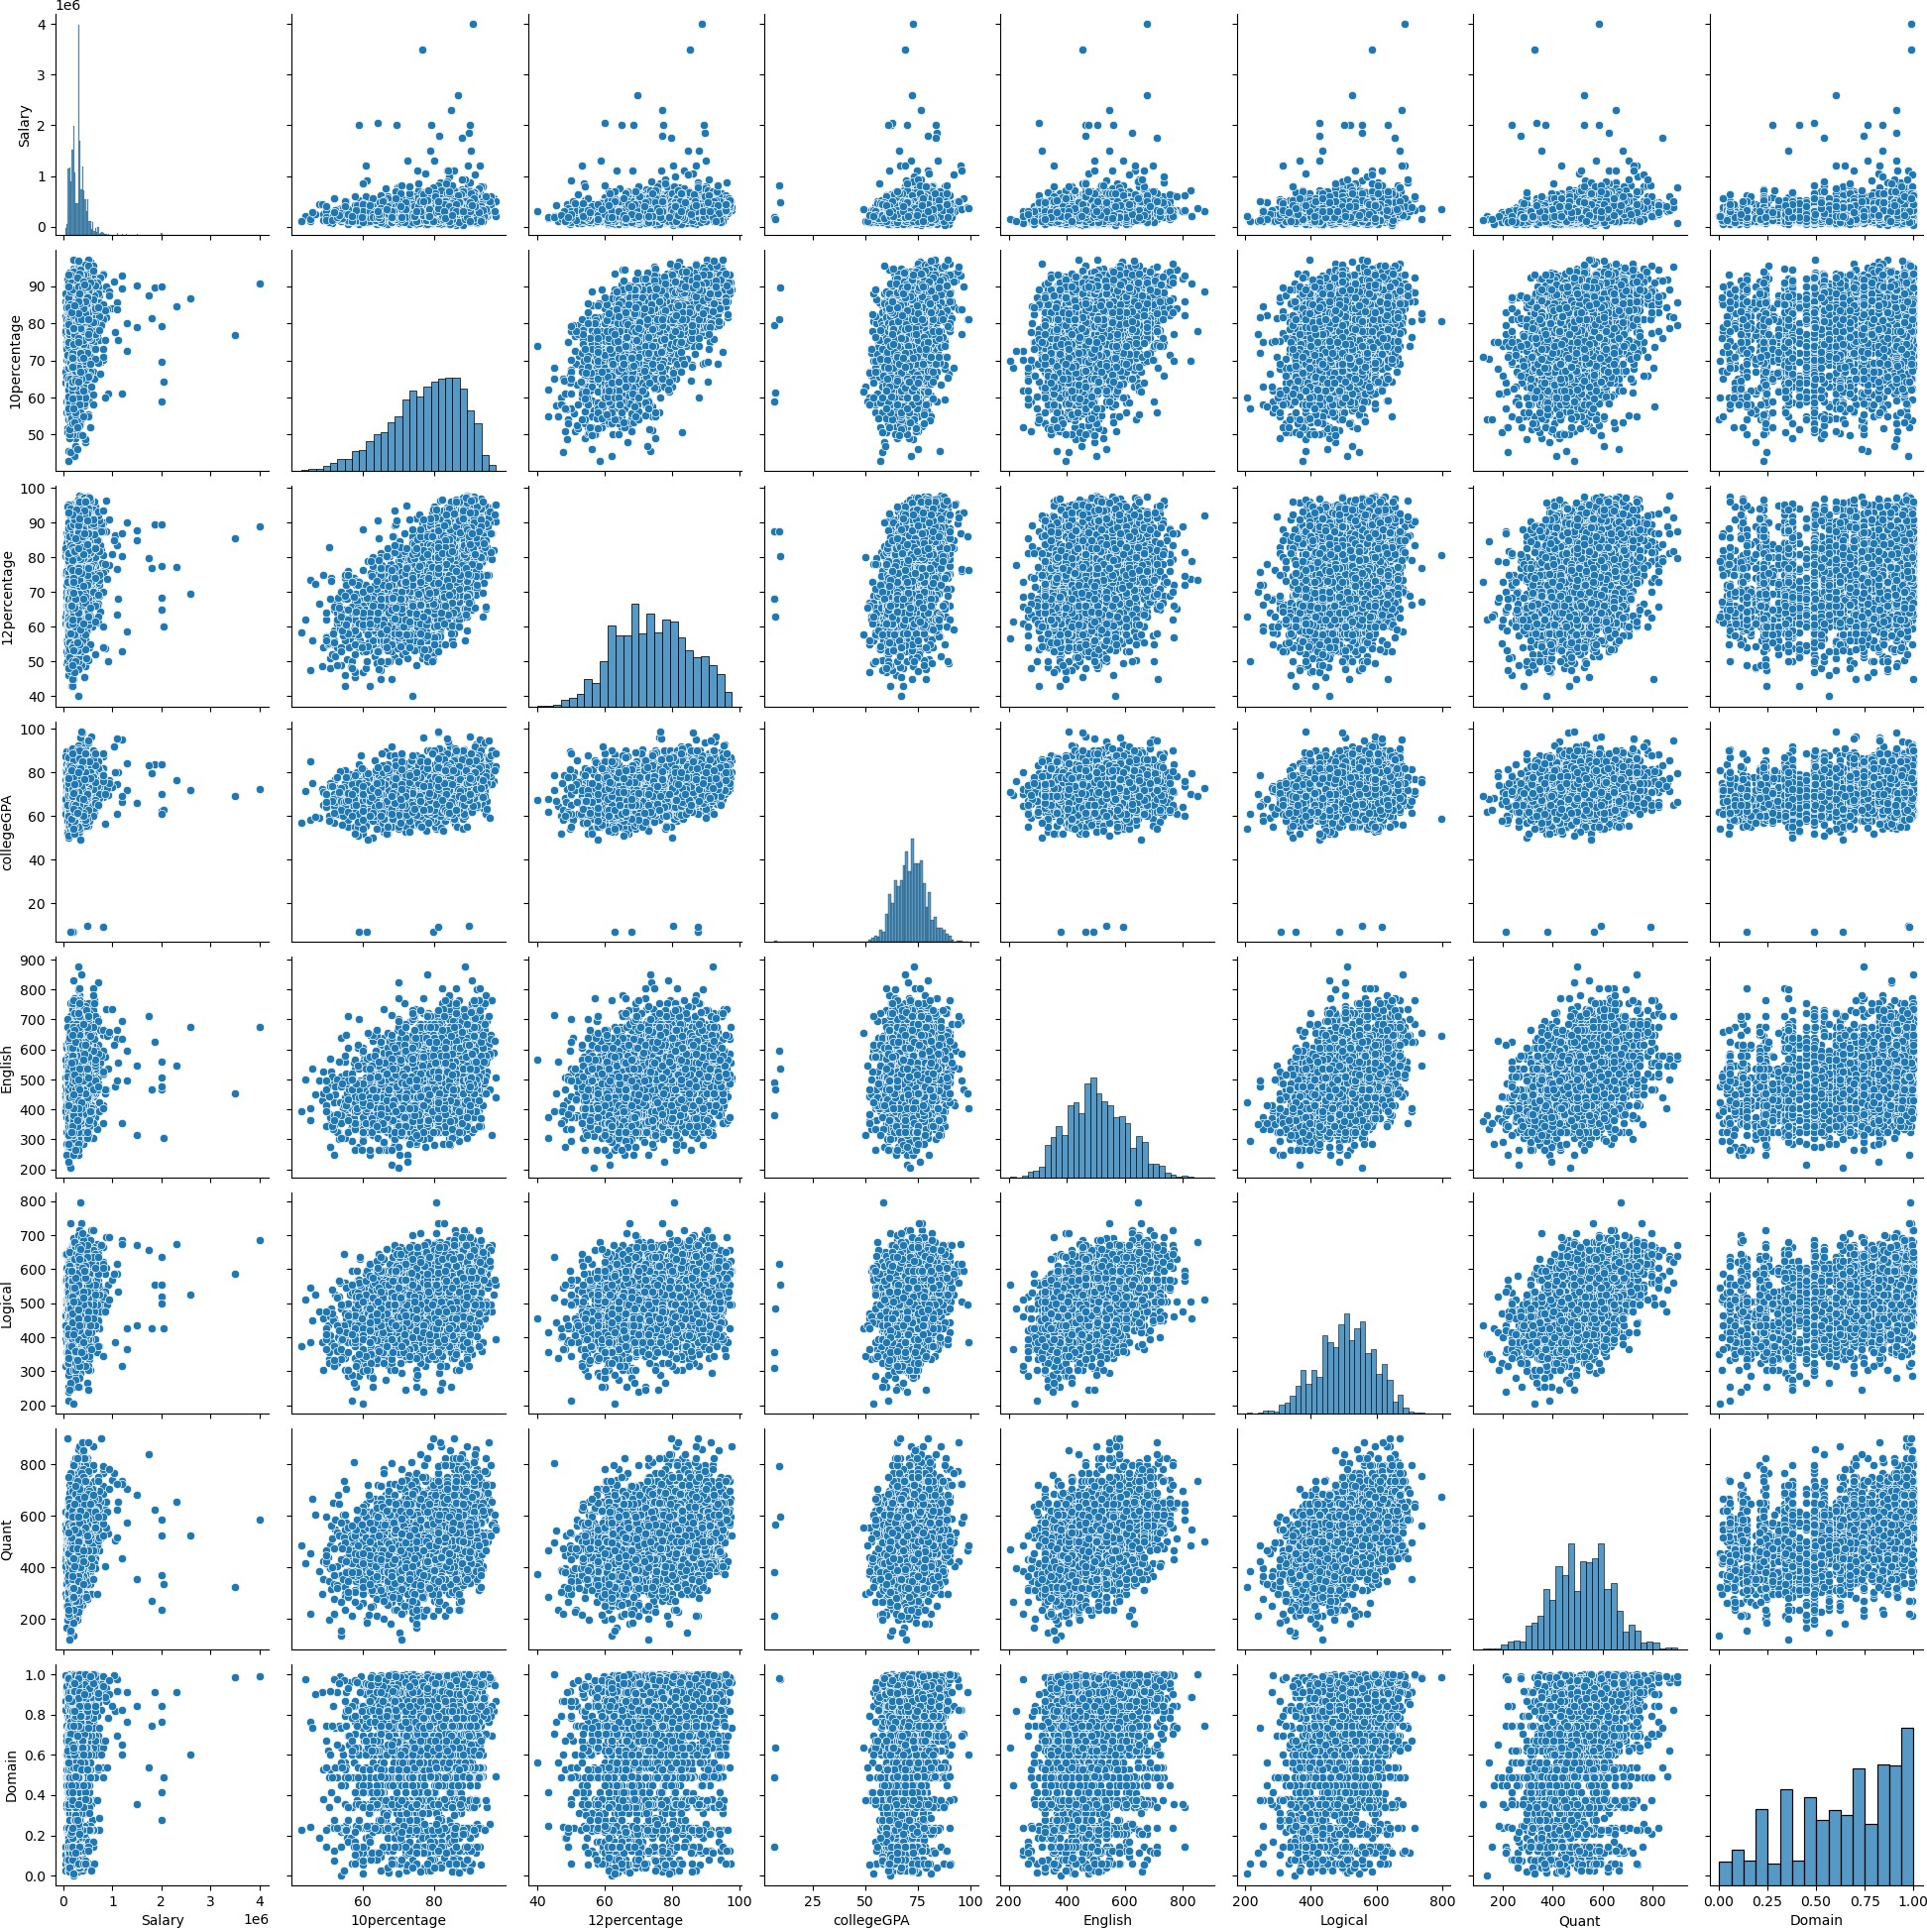

[49]:

# Salary vs Job

[49]: count mean std min 25% 50% \ Job_Role

df.groupby('Job_Role')['Salary'].describe().round(2).sort_values('mean')

Administrator 124.0 232177.42 117028.32 80000.0 150000.0 200000.0

Other 235.0 258170.21 256590.59 45000.0 145000.0 200000.0

|  |  |  |  |  |  |  |  |
| --- | --- | --- | --- | --- | --- | --- | --- |
| Developer | 599.0 | 269098.50 | | 211345.08 | 60000.0 | 145000.0 | 240000.0 |
| Hardware Engineer | 220.0 | 306568.18 | | 182966.85 | 50000.0 | 183750.0 | 295000.0 |
| Analyst | 302.0 | 318907.28 | | 135441.19 | 50000.0 | 210000.0 | 312500.0 |
| Test Engineer | 118.0 | 331610.17 | | 158412.10 | 60000.0 | 200000.0 | 325000.0 |
| Manager | 68.0 | 342279.41 | | 216204.43 | 50000.0 | 205000.0 | 300000.0 |
| Software Engineer | 710.0 | 354957.75 | | 233538.42 | 50000.0 | 240000.0 | 320000.0 |
| System Engineer | 333.0 | 362417.42 | | 202256.69 | 35000.0 | 320000.0 | 335000.0 |
| Job_Role | 75% | | max | | | | |
| Administrator | 287500.0 | | 910000.0 | | | | |
| Other | 267500.0 | | 2000000.0 | | | | |
| Developer | 340000.0 | | 2600000.0 | | | | |
| Hardware Engineer | 381250.0 | | 1860000.0 | | | | |
| Analyst | 368750.0 | | 800000.0 | | | | |
| Test Engineer | 415000.0 | | 900000.0 | | | | |
| Manager | 403750.0 | | 1300000.0 | | | | |
| Software Engineer | 413750.0 | | 4000000.0 | | | | |
| System Engineer | 420000.0 | | 3500000.0 | | | | |

[50]:

order = df.groupby('Job_Role')['Salary'].mean().sort_values().index

[51]:

fig, (ax1, ax2) = plt.subplots(2, 1, figsize=(8,8)) sns.barplot(x='Job_Role', y='Salary', data=df, order=order, ax=ax1) sns.boxplot(x='Job_Role', y='Salary', data=df, order=order, ax=ax2) ax1.tick_params('x', labelrotation=90)

ax2.tick_params('x', labelrotation=90) plt.tight_layout() plt.suptitle('Salary')

plt.show()

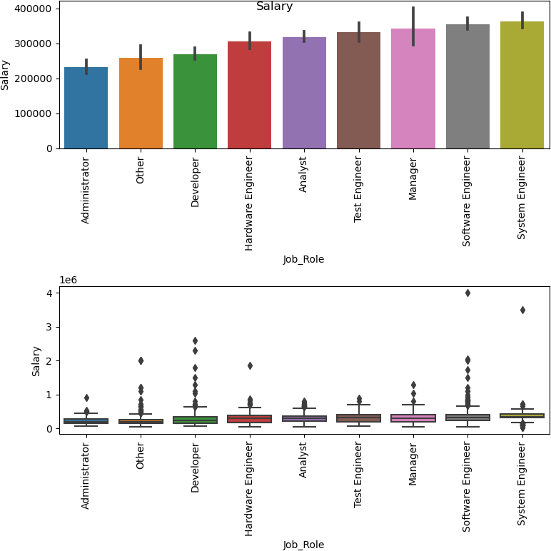

## Observation:

* + - * By the above graph Managers are Earning More than others.
      * The second Most Earner from the plot is System Engineer

# Salary vs CollegeTier

[31]:

df.groupby('CollegeTier')['Salary'].describe()

[31]: count mean std min 25% 50% \ CollegeTier

|  |  |  |
| --- | --- | --- |
| 1 | 207.0 453864.73430 | 355333.55185 100000.0 310000.0 360000.0 |
| 2 | 2502.0 301984.41247 | 189070.38349 35000.0 180000.0 300000.0 |

|  |  |  |
| --- | --- | --- |
| CollegeTier | 75% | max |
| 1 | 500000.0 | 4000000.0 |
| 2 | 370000.0 | 3500000.0 |

[32]:

fig, (ax1, ax2) = plt.subplots(1, 2, figsize=(12,4)) sns.barplot(x='CollegeTier', y='Salary', data=df, ax=ax1) sns.boxplot(x='CollegeTier', y='Salary', data=df, ax=ax2) plt.suptitle('Salary')

plt.show()

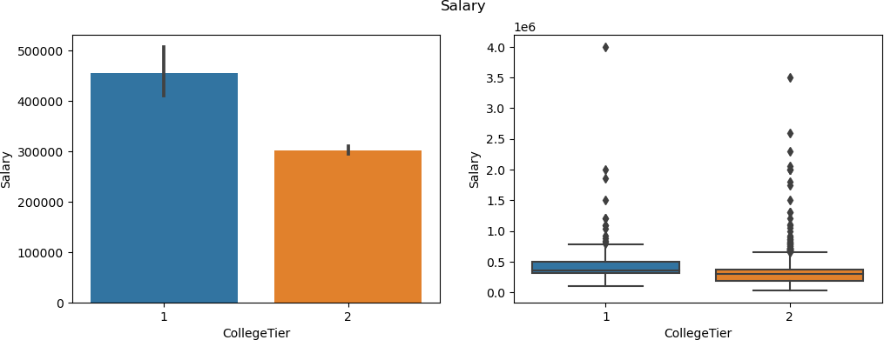

[36]:

## 0.11.1 Observation:

The people who are from Tier-1 college are Earning More as compared to Tire-2

# Salary vs Specialization

df.groupby('Specialization')['Salary'].describe().round(1).sort_values('mean')

|  |  |  |  |  |  |  |  |
| --- | --- | --- | --- | --- | --- | --- | --- |
| [36]: | Specialization | count | mean | std | min | 25% | 50% \ |
|  | MECH | 4.0 | 273750.0 | 78249.1 | 180000.0 | 225000.0 | 282500.0 |
|  | other | 9.0 | 287222.2 | 174393.8 | 100000.0 | 200000.0 | 235000.0 |
|  | ECE | 640.0 | 311312.5 | 181752.2 | 45000.0 | 200000.0 | 300000.0 |
|  | CSE | 2012.0 | 312676.4 | 216744.0 | 35000.0 | 185000.0 | 300000.0 |
|  | EEE | 23.0 | 382826.1 | 351980.8 | 110000.0 | 205000.0 | 335000.0 |
|  | CE | 21.0 | 413571.4 | 214302.0 | 110000.0 | 295000.0 | 345000.0 |
| Specialization | | 75% | max | | | | |
| MECH | | 331250.0 | 350000.0 | | | | |

|  |  |
| --- | --- |
| other | 325000.0 700000.0 |
| ECE | 361250.0 2300000.0 |
| CSE | 385000.0 4000000.0 |
| EEE | 407500.0 1860000.0 |
| CE | 600000.0 800000.0 |

[37]:

order = df.groupby('Specialization')['Salary'].mean().sort_values().index

[38]:

fig, (ax1, ax2) = plt.subplots(1, 2, figsize=(12,4)) sns.barplot(x='Specialization', y='Salary', data=df, order=order, ax=ax1) sns.boxplot(x='Specialization', y='Salary', data=df, order=order, ax=ax2) ax1.tick_params('x', labelrotation=90)

ax2.tick_params('x', labelrotation=90) plt.suptitle('Salary')

plt.show()

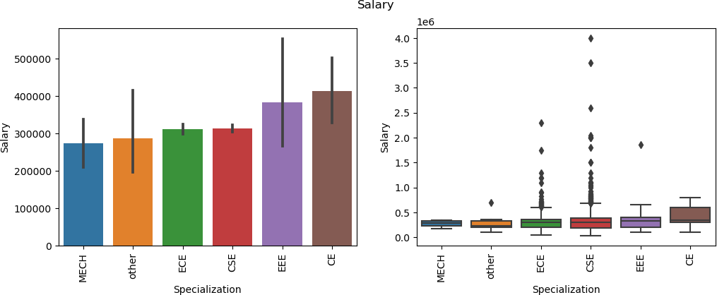

[39]:

## Observation:

CSE people are earning more as compared to other students

# Salary vs Degree

df.groupby('Degree')['Salary'].describe()

|  |  |  |  |  |  |  |
| --- | --- | --- | --- | --- | --- | --- |
| [39]: | Degree | count | mean | std | min | 25% \ |
|  | B.Tech/B.E. | 2460.0 | 317081.300813 | 211143.976154 | 35000.0 | 200000.0 |
|  | M.Sc. (Tech.) | 1.0 | 180000.000000 | NaN | 180000.0 | 180000.0 |
|  | M.Tech./M.E. | 34.0 | 406470.588235 | 347705.747706 | 65000.0 | 200000.0 |
|  | MCA | 214.0 | 259322.429907 | 156805.353943 | 60000.0 | 145000.0 |

50% 75% max

|  |  |  |
| --- | --- | --- |
| Degree |  | |
| B.Tech/B.E. 300000.0 | 381250.0 | 4000000.0 |
| M.Sc. (Tech.) 180000.0 | 180000.0 | 180000.0 |
| M.Tech./M.E. 345000.0 | 448750.0 | 1860000.0 |
| MCA 217500.0 | 325000.0 | 1200000.0 |

[40]:

fig, (ax1, ax2) = plt.subplots(1, 2, figsize=(12,4)) sns.barplot(x='Degree', y='Salary', data=df, ax=ax1) sns.boxplot(x='Degree', y='Salary', data=df, ax=ax2) plt.suptitle('Salary')

plt.show()

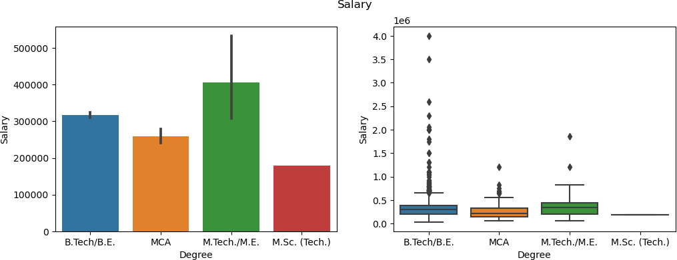

[54]:

## Observation:

M.Tech/M.E students are earning More than others, but B.Tech/B.E Students having more chances to earn better than M.Tech Students.

## Numerical vs. Numerical Relationships

*# Scatter Plot for Salary vs Other Numerical Columns* plt.figure(figsize=(10, 6)) sns.scatterplot(x='10percentage', y='Salary', data=df) plt.title('Salary vs 10th Percentage')

plt.show()

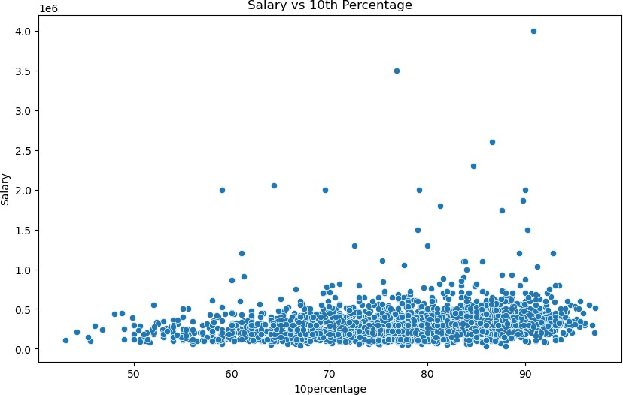

[56]:

*# Hexbin Plot for Salary vs 10percentage*

plt.figure(figsize=(10, 6))

plt.hexbin(df['10percentage'], df['Salary'], gridsize=50, cmap='Blues') plt.colorbar()

plt.title('Hexbin Plot of Salary vs 10th Percentage') plt.xlabel('10th Percentage')

plt.ylabel('Salary') plt.show()

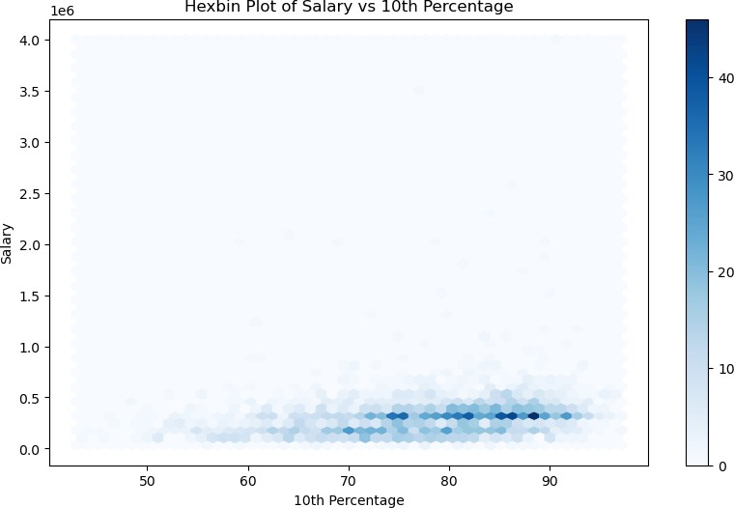

## Categorical vs. Numerical Relationships

[57]:

*# Boxplot to compare Salary across different Gender*

plt.figure(figsize=(10, 6)) sns.boxplot(x='Gender', y='Salary', data=df) plt.title('Salary vs Gender')

plt.show()

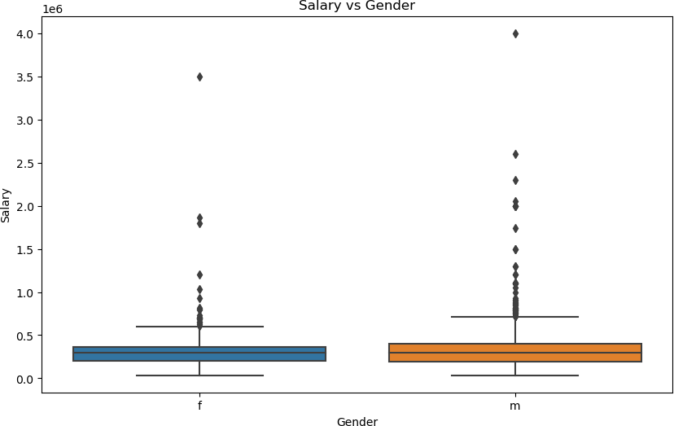

[58]:

*# Swarmplot for Salary vs Degree* plt.figure(figsize=(10, 6)) sns.swarmplot(x='Degree', y='Salary', data=df) plt.title('Salary vs Degree')

plt.show()

C:\ProgramData\Anaconda3\lib\site-packages\seaborn\categorical.py:1296: UserWarning: 88.4% of the points cannot be placed; you may want to decrease the size of the markers or use stripplot.

warnings.warn(msg, UserWarning)

C:\ProgramData\Anaconda3\lib\site-packages\seaborn\categorical.py:1296: UserWarning: 36.9% of the points cannot be placed; you may want to decrease the size of the markers or use stripplot.

warnings.warn(msg, UserWarning)

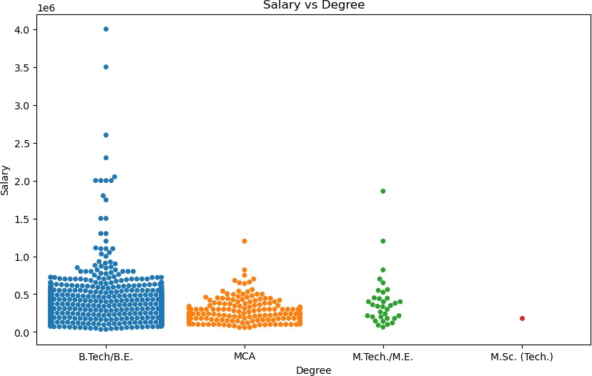

[59]:

*# Barplot for Salary vs Degree* plt.figure(figsize=(10, 6)) sns.barplot(x='Degree', y='Salary', data=df) plt.title('Average Salary vs Degree') plt.show()

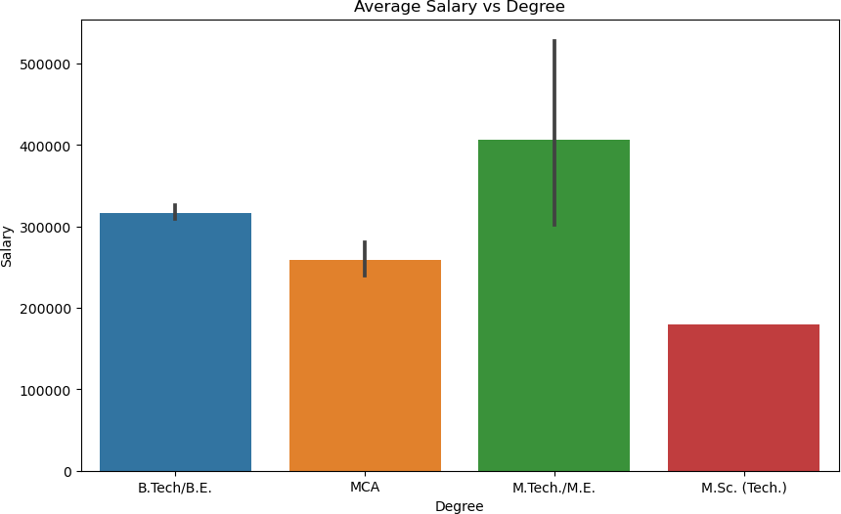

## Categorical vs. Categorical Relationships

[61]:

*# Stacked Bar Plot for Degree and CollegeCityTier*

cross_tab = pd.crosstab(df['Degree'], df['CollegeCityTier']) cross_tab.plot(kind='bar', stacked=**True**, figsize=(10, 6)) plt.title('Degree vs College City Tier (Stacked)') plt.xlabel('Degree')

plt.ylabel('Count') plt.show()

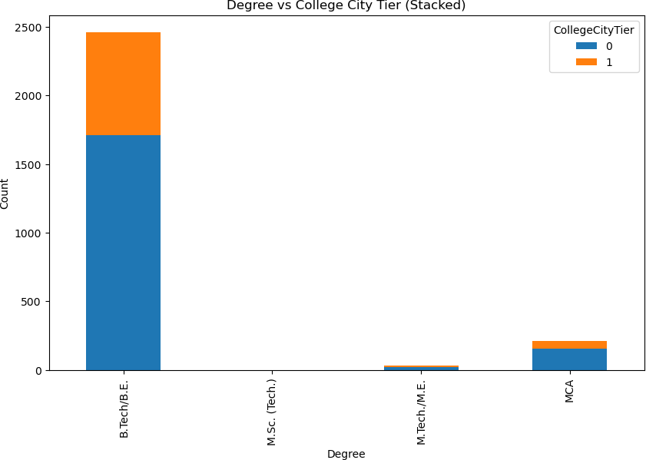

[68]:

*# Filter data for Computer Science Engineering graduates*

cse_graduates = df[df['Specialization'] == 'CSE']

*# List of job roles to consider*

roles_of_interest = ['Programming Analyst', 'Software Engineer', 'Hardware␣

↪Engineer', 'Associate Engineer']

*# Filter data to only include these roles*

role_data = cse_graduates[cse_graduates['Job_Role'].isin(roles_of_interest)]

*# Show the salary distribution for these roles*

plt.figure(figsize=(10, 6))

sns.boxplot(x='Job_Role', y='Salary', data=role_data)

plt.title('Salary Distribution for Computer Science Engineering Graduates in␣

↪Selected Job Roles') plt.xticks(rotation=45) plt.show()

*# You can also check the specific salary range in these roles*

# Step - 5 - Research Questions

salary_range = role_data['Salary'].describe() print(salary_range)

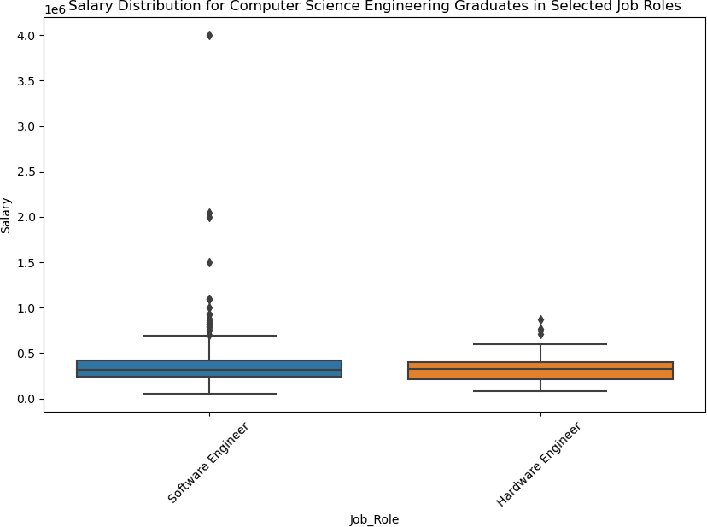

count 6.850000e+02 mean 3.510365e+05

std 2.304520e+05

min 5.000000e+04

25% 2.400000e+05

50% 3.200000e+05

75% 4.150000e+05

max 4.000000e+06

Name: Salary, dtype: float64

[69]:

## Observations

* + 1. **Is there a relationship between gender and specialization? (i.e. Does the pref- erence of Specialisation depend on the Gender?)**

*# Create a contingency table to see the relationship between Gender and*␣

↪*Specialization*

gender_specialization = pd.crosstab(df['Gender'], df['Specialization'])

*# Plot a stacked bar plot*

gender_specialization.plot(kind='bar', stacked=**True**, figsize=(10, 6)) plt.title('Relationship Between Gender and Specialization') plt.xlabel('Gender')

plt.ylabel('Count') plt.show()

*# Alternatively, use a heatmap to visualize the distribution*

plt.figure(figsize=(10, 6))

sns.heatmap(gender_specialization, annot=**True**, cmap='coolwarm', fmt='d') plt.title('Heatmap of Gender vs Specialization')

plt.show()

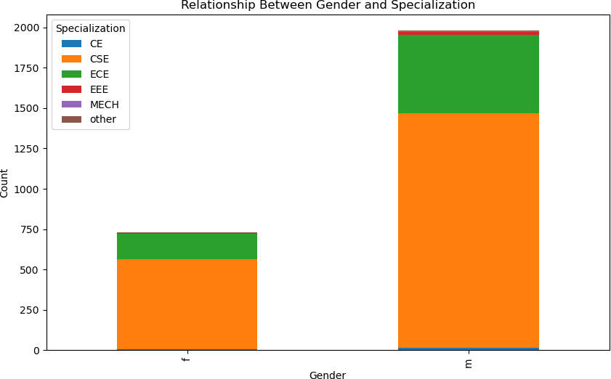

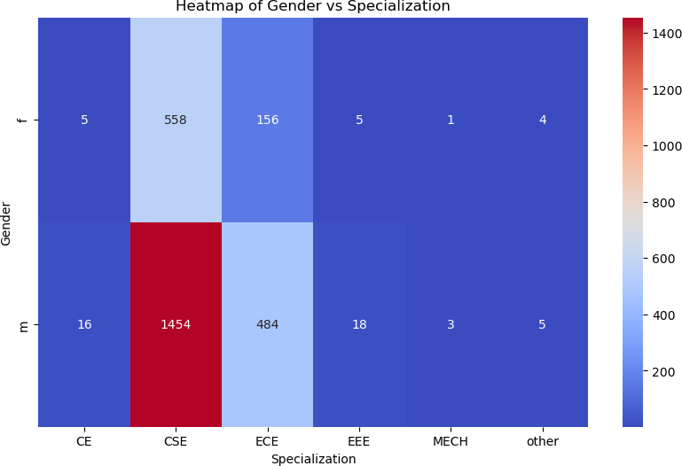

## Observation

* + - * The analysis shows that while both genders show a preference for CSE, the male students dominate in terms of number. The other specializations (like ECE, EEE) are also selected by both genders, but CSE remains the most popular overall, especially among male students.

# Step - 6 - Conclusion

* Technical expertise is crucial: The prevalence of Bachelor of Technology/Engineering gradu- ates reflects the high demand for technical skills in the job market.
* Earnings by Role: Managerial and technical positions are the highest-earning roles, empha- sizing the value placed on leadership and technical expertise.
* Impact of College Tier: Graduates from Tier-1 colleges consistently earn higher salaries than those from other tiers.
* Gender-Based Salary Differences: While there are some salary disparities between genders, the results warrant further investigation to understand the exact factors contributing to this.
* No Support for Claim on Fresh Graduate Earnings: The data does not support the claim of 2.5-3 lakh earnings for Computer Science graduates, suggesting that salaries may not align with the general assumptions.
* Gender and Specialization Preference: No significant relationship exists between gender and specialization preferences, challenging common assumptions about the correlation.

[ ]:

* Salary Insights:
  + Computer Science & Engineering (CSE) specialization has the highest median salary.
  + On average, females earn 203,648.65, while males earn 194,105.26, with males being slightly under this average.
  + The highest average salary is associated with CSE at 209,166.67 per year.
  + Dominant Roles: The Software Engineer domain employs the largest number of gradu- ates, showcasing the demand for this role in the market.
* Specialization Choices:
  + CSE graduates are the most likely to pursue specialization courses related to their degree.
  + Females tend to opt for Information Technology (IT), while males are more likely to choose Computer Science as their specialization.
  + Average Graduate Salary: Graduates with a B.Tech/B.E. degree generally expect an average salary of 200,000 annually.